** **

**Sneaker Classification Using TensorFlow**

**By**

**Aruviyn Varmaa**

**TP057988**

**UC3F2111CS(IS)**

A project submitted in partial fulfillment of the requirements of Asia Pacific University of Technology and Innovation for the degree of

**Bachelor of Computer Science (Hons) Intelligent System**

Supervised by Mr. Zailan Arabee Abdul Salam

2nd Marker: Dr. Kadhar Batcha

April 2022

# **Acknowledgements**

I am deeply grateful and thankful to God for giving me strength and his continuous

blessings in completing this research. I would like to express my gratitude to my

supervisor, Mr. Zailan Arabee Abdul Salam for his continuous guidance, dedication

and patience in every step of the entire research. I have gained and learnt a lot of things from his teachings and passion in regards to this field.

I would also like to sincerely thank all the lecturers of School of Computing and Technology for assisting and supporting in completing this research. I appreciate their support and encouragement in times of peaks and valleys.

Last but not least, I would like to take this opportunity to thank my family and friends for their endless support and love regardless of this research or throughout my undergraduate studies. All in all, thank you to all who have helped in this research directly or indirectly.

Sincerely,

Aruviyn Varmaa

**Table of Contents**

Contents

**Acknowledgements** 2

**Chapter 1: Introduction to the Study** 7

1.1 Background to the Project 7

1.2 Problem Context 8

1.3 Rationale 9

1.4 Potential Benefits 9

1.4.1 Tangible Benefits 9

1.4.2 Intangible Benefits 9

1.5 Target Users 10

1.6 Scope and Objectives 10

1.6.1 Aims 10

1.6.2 Objectives 10

1.6.3 Deliverables 11

1.6.4 Nature of Challenges 11

1.7 Overview of this report 12

1.8 Project Plan 14

**Chapter 2: Literature Review** 15

2.1 Introduction 15

2.2 Domain Research 15

2.2.1 Image Recognition Technology Based on Machine Learning 15

2.2.2 The Importance and Understandings of Sneakers And Sneaker Market. 19

2.3 Similar Systems 21

2.3.1 CloudVision API 21

2.3.2 Imagga 22

2.3.3 Microsoft Image Processing API 23

2.4 Summary 23

**Chapter 3: Technical Research** 24

3.1 Programming Languages 24

3.1.1 JavaScript and Python 24

3.2 Integrated Development Environment (IDE) 25

3.2.1 Visual Studio Code 25

3.2.2 Jupyter Notebook 26

3.3 Libraries and Tools 26

3.3.3 TensorFlow.js 28

3.4 Database Management System (DBMS). 28

3.4.1 Firebase Realtime Database 28

3.4.2 DB2 28

3.4.3 Comparative Analysis Justification. 29

3.5 Operating System 29

3.6 Web Server 29

3.7 Web Browser 30

3.8 Summary 31

3.8.1 Justification of Changes in Summary 31

**Chapter 4: System Development Methodology** 32

4.1.1 Waterfall Methodology 34

4.1.2 Rapid Application Development (RAD) 35

4.1.3 Comparative Analysis between Waterfall Methodology and RAD Methodology. 37

4.2 Justification 38

4.3 Overview of Project 38

**Chapter 5: Research Methods** 40

5.1 Introduction 40

5.2 Questionnaire 41

5.3 Questionnaire Design 42

5.4 Summary 54

**Chapter 6: Requirements Validation** 55

6.1 Analysis of Data Collected Through Questionnaire 55

6.2 Summary 74

**Chapter 7: System Architecture** 75

7.1 Introduction 75

7.2 Abstract Architecture 76

7.2.1 System Design – Sneaker Classifier Use Case Diagram 76

7.2.2 System Design 79

7.2.3 Data Table Structure 79

7.2.3 Interface Design 80

**Chapter 8: Project Plan** 81

8.1 Release Plan 81

8.1.1 Sneaker Classifier Version 1.1 81

8.1.2 Sneaker Classifier Version 1.2 81

8.1.3 Sneaker Classifier Version 13 81

8.1.4 Sneaker Classifier Version 1.4 81

8.1.5 Sneaker Classifier Version 1.5 82

8.2 Project Test Plan 82

8.2.1 Unit Testing Plan 82

8.2.2 User Acceptance Plan 85

**Chapter 9: Implementation** 87

9.1 Screenshots 87

9.1.1 Login Page User Interface (UI) 87

9.1.2 Dashboard UI 89

9.1.3 Prediction UI 90

9.2 Sample Codes 92

9.2.1 TensorFlow Libraries 92

9.2.2 TensorFlow Model 93

9.2.3 Testing the Model 94

9.2.4 Converting the Model. 95

9.2 System Implementation. 95

9.2.5 Naming the classes for prediction 95

9.2.6 Uploading image function 97

9.2.7 Prediction function 98

9.2.8 Importing TensorFlowJS model 99

9.2.9 Button and id 100

**Chapter 10: System Validation** 101

10.1 Unit Testing Results – Sneaker Classification System 101

10.2 User Acceptance Testing Result – Sneaker Classification System 103

10.3 Summary 107

**Chapter 11: Conclusion and Reflections** 108

11.1 Critical Evaluation 108

11.1.1 Aims and Objectives of the System 108

11.1.2 System Limitations 108

11.1.3 Future works for the system 109

11.1.4 Evaluation on Methodology Used 109

11.1.5 Evaluation Summary 110

11.2 Conclusion 110

11.2.1 System Limitation 110

11.2.2 Reflection 111

**References** 112

1.0 Bibliography 112

**Appendices** 118

1.0 Project Poster 118

2.0 Log Sheet 119

Project Log Sheet 1 119

Project Log Sheet 2 120

Project Log Sheet 3 121

3.0 Ethic Form 122

4.0 Project Proposal Form (PPF) 126

5.0 Project Specification Form 129

6.0 Gantt Chart 136

7.0 Confidentiality Form 137

8.0 Library Catalog Form 138

# **Chapter 1: Introduction to the Study**

## Background to the Project

Sneakers was once known as the symbol of athleticism and have transcended its prime function to become commercial and fashionable wears of decide. From a sportswear, it has now also been used for catwalk fashions, sneakers are now marked as cultural commodities. The sneaker market is blooming and globally it is valued approximately at $70 billion in the year 2020. With this huge profit, it is no surprise that sneakers are considered as a big business (Braithwaite, N. 2021). With the global sneaker market blooming, the problem of confusion between an originally made sneaker and an imitation of sneakers will has occurred. In the year 2019, sneakers are known as the second most counterfeited product that was produced. This issue has caused huge damage which has affected customers who purchased counterfeit sneakers (Locator X, 2019).

Apart from that, sneakers are produced in various color schemes to meet the demand of users. Sporting goods company tend to come up with new ideas to produce colors that are unique to attract customers. The same design of sneakers is produced in different colors to provide a wider choice for customers in purchasing sneakers. Although these same design sneakers are produced in different colors, they are still labelled in the same sneaker model. What differentiates this same design but different colored sneakers are the name of them. For example, Nike Air Force 1 Fontana Light Madder Root color variant and Nike Air Force 1 Fontanka University Blue color variant belong to the same model. This can lead to confusion among users when the model of the shoe is known but uncertainty on which color is directed to.

There are several ways on identifying the difference of color variant and model of sneakers. However, it would be time consuming to research on all the methods to identify all individual sneaker brand or model. Purchasing online would be more problematic as images shown online are not definitely original when delivered to the doorstep. With the help of artificial intelligence, computer vision can be used to recognize sneakers’ model. To us human observer, two sneakers that may look identical with one may belong to the same model but is not. But the machine learning beat human eyes in detecting details (Brouton lab, n.d.). This project to use artificial intelligence to enable sneaker brand and model of a sneaker.

## Problem Context

The problem area revolves around the time-consuming methods on recognizing unknown model of sneakers on the streets. With the difficulty of identifying model of a sneaker, customers have to research beforehand to find out different sneaker models before purchasing products, especially online.

There are various resources online such as YouTube videos, blogs, official webpages, and many more for customers to identify different models of sneakers, but with this method, it is very time consuming for customers to identify them as there are similar models that look alike but do not belong to the same model. For example, there are numerous Adidas Yeezy’s such as Yeezy Boost 350, Yeezy Boost 350 v2, Yeezy Boost750, and Yeezy Boost950 which look almost similar but belong to the different model.

Besides that, it is also difficult to differentiate the colour variation of sneakers due to the complexity of the colour name such as Clay Green, Midnight Navy and Varsity Blue. The difficulty in identifying the right colour with cause confusion especially when sellers sell sneakers via online to customers. The problem for this system is about having large enough dataset to train the system and choosing the right machine learning algorithm.

## Rationale

According to the problems mentioned above, the proposed sneaker recognition system will be implemented as a web application system. This web application can be implemented on either user’s laptop, personal computer, or even in the mobile. The web application will be utilizing web application for this system to do the purpose. Users are required to input images to identify and recognize sneakers in the image. It saves time for users as they can check the details of the sneaker instead of them consume time and have the hassle to search online. User can also easily identify sneakers wore by another person by just capturing an image of the sneaker and feeding it into the system.

## 1.4 Potential Benefits

The potential benefit of this project can be divided into two categories which are the tangible benefits and the intangible benefits. Tangible benefits are measurable and quantifiable whereas intangible benefits are not quantified but are subjective (Capozzi, C. 2017). The next part of this project highlights the potential of the tangible and intangible benefits.

### 1.4.1 Tangible Benefits

* Quality Control from retail stores reduces manpower with this system being used.
* Users can identify sneakers in a nick of time.

### 1.4.2 Intangible Benefits

* Provides convenient for users to identify sneakers anywhere.
* Saves times on using other methods to identify and recognize sneakers.
* Users can identify sneakers anywhere before purchasing or trading.

## Target Users

The proposed system is targeted for users who often purchases or trade sneakers, and for quality control workers in retail shops or outlets to have more convenience in checking sneaker models. However, despite having specific target users, the system will also be available for public users as the system is integrated for public as well.

## Scope and Objectives

The scope of the project are the steps required to successfully dispatch this system. As for the objectives of the project, it is the goals needed to be achieved by the end of the project.

### 1.6.1 Aims

The aim of this project is to integrate the system into a web application where users can utilize the system through any device that can connect to the browser. This allows users to recognize and identify sneakers at any devices they have. The system requires user to feed sneaker image for it to provide the brand, mode, and color variant of the sneaker.

### 1.6.2 Objectives

The objectives of this project are such as stated below:

* Design a user-friendly graphical user interface (GUI) for easy understanding and navigation.
* To obtain large dataset for training.
* To develop and train machine learning for high accuracy.
* Integrate the system into a web application
* To do all tests before deploying the system.

### 1.6.3 Deliverables

There will only be one type of user for this system. This is because the purpose of this system is to identify and recognize sneakers. The system will be implemented in a web application. First, a large amount and variety of sneaker datasets are needed, then train it with an algorithm tool, and stored in a local database. Once the datasets are trained, the system will be able to identify the sneakers accordingly. A machine learning tool will be implemented for the dataset training which allows the machine learning model to make sequence decisions. The computer will employ trial and error to provide a solution to the problem (Konrad B, 2018). The system also requires a user-friendly interface for the sneaker information to be displayed. The following shows what users are allowed to do with the system.

* Allows users to input images of sneaker into the system.
* Allows users to view the brand of the sneaker
* Allows users to view the model of the sneaker
* Allows users to view the color variant of the sneaker

### 1.6.4 Nature of Challenges

To develop the sneaker identification system, a large amount of sneaker dataset which consist of color variant of all different types of models and brand are required for training. Machine learning and neural network knowledge is required for development and implementation. During the training phase, research must be done on which deep learning and neural network to be used. Same goes to the implementation phase, research must also be done on which machine learning tools to be used. The tools used for this system plays a crucial role on the accuracy of this system. Apart from that, the user interface for this system will also be designed to be in a user-friendly manner for easy understanding and navigation of the system.

## Overview of this report

This report is broken down into seven chapters with different purposes. The seven chapters are as mentioned below.

1. Introduction to the study

This first chapter covers the research foundation. It is mainly about the background research of this project and the discussion of problem. Apart from that, the most important part of this section is the scopes and objectives of the project which also includes the aims, deliverables, and the nature of challenge.

1. Literature Review

Literature review is the study of previous and similar research done by other researchers. The purpose of doing a literature review is to properly understand the nature of this project as well as the challenges.

1. Technical Research

Chapter 3 is the technical research where all technical requirements and tools are discussed and justified for this project. Apart from discussion and justification, there is also comparison between two programming language chosen for this project, comparison for choosing a database management system.

1. System Development Methodology

In this chapter, a system development methodology is selected. Another methodology will be used for comparison analysis purpose. The selected methodology will be discussed and an overview on how the project will proceed with the methodology will be discussed.

1. Research Method

This chapter involves data gathering and analysis that will reflect on this project. The data gather method used is discussed and justified. A sample of data gathering method will be provided for reference purpose.

1. Analysis

From chapter 5 data gathering method, the result analysis will be discussed in this chapter which is the requirements validation chapter. Analysis is conducted from the data obtained through the selected method. The data obtained is to have more understand on the project along with potential improvements.

1. System Architecture

This chapter discuss the core features and element that are implemented in the project system, architecture of system design, database design, and interface design.

1. Project Plan

The project plan chapter is the discussion of details of plan released and test plan. Details of plan released is the number of times a working system is implemented along with its functions, and the test plan discusses test development strategies, unit testing, and user acceptance testing.

1. Implementation

In this chapter, there will be discussion of the code snippets along with screenshots provided for each page in the user interface.

1. System Validation

The system validation chapter is the discussion of unit testing done, user acceptance testing done, and a summary of the system validation, after the deployment of the system.

1. Conclusion and Reflections ### Might need to add

The last chapter involves summarizing the whole report and what was achieved as well. It also involves identifying flaws in the researched and what needed to be explored further. Towards the end of the chapter, a list of references cites for the report, appendices including log sheets, project proposal form (PPF), project specification form (PSF), ethic form, and Gantt chart is required to complete the report whole.

## 1.8 Project Plan

In this section, a project plan will be provided which displays the plan of this project along with the overall timeline. A table will be provided for more detailed structure of the tasks done.

|  |  |  |  |  |
| --- | --- | --- | --- | --- |
| **Project Plan** | | | | |
| **Tasks Name** | **Duration** | **Start Date** | **End Date** | **Status** |
| System machine learning model | 36 days | 23/4/2022 | 29/5/2022 | Completed |
| Model training | 14 days | 30/5/2022 | 12/6/2022 | Completed |
| Chapter 1: Introduction to the Study | 7 days | 18/4/2022 | 24/4/2022 | Completed |
| Chapter 2: Literature Review | 7 days | 25/4/2022 | 1/5/2022 | Completed |
| Chapter 3: Technical Research | 8 days | 2/5/2022 | 9/5/2022 | Completed |
| Chapter 4: System Development Methodology | 2 days | 10/5/2022 | 11/5/2022 | Completed |
| Chapter 5: Research Methods | 3 days | 12/5/2022 | 14/5/2022 | Completed |
| Chapter 6: Requirement Validation | 2 days | 15/5/2022 | 16/5/2022 | Completed |
| Chapter 7: System Architecture | 6 days | 17/5/2022 | 22/5/2022 | Completed |
| Chapter 8: Project Plan | 7 days | 13/6/2022 | 19/6/2022 | Completed |
| Chapter 9: Implementation | 14 days | 20/6/2022 | 3/7/2022 | Completed |
| Chapter 10: System Validation | 8 days | 4/7/2022 | 11/7/2022 | Completed |
| Chapter 11: Conclusion and Reflections | 6 days | 12/7/2022 | 17/7/2022 | Completed |

*Table 1 – Project Plan*

# **Chapter 2: Literature Review**

## 2.1 Introduction

This section contains literature review details and discussion that was done for this project. The domain research is a literature review done that was based on several journals that is available online in the field of image recognition and identification techniques. The next part of the literature review is the similar system where analysis and comparison between different tools systems and tools from the research done, along with the pros and cons of it.

## 2.2 Domain Research

### 2.2.1 Image Recognition Technology Based on Machine Learning

According to a research paper from Liu et.al. (2020) there were many problems unsolved even with the development of machine learning such as speech recognition, natural language processing, image classification, location detection, image generation, and so on. In the field of deep learning, it is known that the most basic, traditional, and urgent research is always image classification. The technology from machine learning which is image processing is commonly used in classification, feature image, recognition, segmentation, and often used in various other fields. However, classification accuracy is important but difficult due to complexity of video images and the objects distributed in different background applications. The researchers applied image recognition technology to recognize license plate with complicated background to extract the license plate from the paper transportation industry, segment the characters of the license plate, and to recognize the characters. They then construct a machine learning non license plate automatic generation algorithm that improves the recognition of non-license plate vehicles. The researchers used genetic algorithm to optimize BP neural network so that they can classify the anti-interference ability, license plate information, and recognition of license plate accuracy was improved to a certain extent.

A research paper done by Khalifa et.al. (2007) mentioned that the image processing technology can be used in many different security and traffic applications like to find stolen cars, controlling access to car parks, and gathering the flow of traffic statistics. In this paper the approach is to do license plate localization and recognition which performs license plate recognition under any environmental conditions without the assumption on orientation of the license plate or the distance from the camera. To solve the problem, researchers used a texture-based approach based on edge information. The characters segmentation is done through connected components analysis on the license plate images and a multi-layer perceptron neural network to recognize it. The results gained was more effective for a real time license plate recognition.

Another research on license plate recognition done was done by Li Yao et.al. (2019). The researchers proposed an SSD-based end to end license plate recognition system. The license plate recognition SSD network architecture contains two classification networks. The first is upper layer network that is used to detect vehicle license and classify them, the second is the lower layer network that is used to detect character of license plate and classification. To enhance the performance, the researchers synthesized 50 thousand simulated license plate for each type of license plate. The result of this network achieved faster convergence speed during training, and the accuracy of license plate detection and classification reached up to 98.3%, the character recognition up to 99.1%.

A research paper on image classification model based on deep convolution neural network was done by Xin, M & Wang, Y (2019). The researchers proposed a creative training criterion of depth neural network for maximum minimum error in classification. They also combined the cross entropy and M3C3 for better results and tested that the M3C3-C3c on the two deep learning standard databases which are CIFAR-10 and MNIST. The results showed that the M3C3 can enhance cross entropy and it was effective supplement to the cross-entropy criterion. Overall, the M3C3-C3c achieved good results in both the databases.

Tanakorn T, et al. and Peeraya et al. both did a proposal based on flower identification system on image processing. The first paper did the image processing through feature extraction, image analysis, and classification whereas the second paper did image acquisition, image segmentation, feature extraction, and classification. The first paper tested the proposed system using 10 flower species with 50 test image per species which sums up to 500 images. The system only used 100 training images that was downloaded from flower dataset online. The proposed system then achieved accuracy rating of 80% from the images. As for the second paper, the researchers performed a test using the proposed system was able to separate the image background from the image foreground and achieve 86.14% accuracy rating. The researchers then used 15 different flowers for the system to classify and achieves 80.67% accuracy. Since both the research paper did almost similar methods, both got almost the same result which leads to 80% of accuracy.

The following research paper is based on flower classification using texture and colour features. The researchers, Riddhi, et.al. (2017) uses image processing techniques which can be used for various reasons such as clustering, image recognition, classification, pattern, or character recognition from videos or images. This technique is a sequence of operation done on images to improve the quality of the images. The researchers face problem as it is difficult to create a flower classification due to the intra-class variation and small inter-class variation among the different classes. The researchers used dataset that is taken from natural environment. The researchers first did pre-process and segmentation on the dataset where the images are first resized into half then images are converted into grayscale and then converted into binary. Since binary has noise the researchers removed the noise by using the maximum connected component to remove the noise. This process will then lead to image that creates a bounding box around the foreground and the segmentation is completed. Using the method of Gray Level Co-occurrence Matrix (GLCM) the texture feature is extracted and the colour features are extracted through Colour Moment which uses probability distribution to measure the characterize colour distribution in an image. The result gotten from the researchers using five tested flower class from 40 different images of each class with the total of 200 images used in this project for the GLCM and Colour Moment method in accuracy are GLCM 40%, Colour Moment 65%, and both GLCM with Colour Moment is 95% accuracy. The researchers plan to improve the accuracy with adding features such as shapes and edges.

Another flower recognition system based on image processing and neural networks paper has been done by different researchers, Huthaifa A, et.al. (2018) using image processing techniques combined with Artificial neural networks (ANN). The dataset obtained by these researchers is from Oxford 102 flowers. As for the methods done by these researchers is divided into four different steps which is image enhancement, image segmentation, feature extraction, and GLCM for the texture descriptor. The overall achieved accuracy rate from this method that the researchers used is at 81.19%. Compared to the researchers Riddhi, et.al., his methods for the flower classification system managed to get higher accuracy than Huthaifa A, et al.

The next research paper by Nguyen N, et al, (2016) regarding the flower identification, they performed the robustness of deep learning on CNN to identify flower species through images. They then applied a comparative study of performance evaluation of CNN which is the CaffeNet, AlexNet and GoogLeNet. Among these three, GoogLeNet has the best performance with the rank 1 accuracy of 67.45% and rank 10 of 90.82% for 967 species flower dataset that has been extracted from PlantCLEF 2015. Compared to the Kernel Descriptor (KDES), these results were six times higher. According to them the proposed method could be the most promising method to help develop searching applications for image-based on fields for botanical classification, multimedia community, or even in systems that monitor ecology.

In this research paper by Bo Y, et al. (2020) reviewed, the object tracking framework use for vehicle tracking in intelligent transport and traffic detection used is the detection-based tracking (DBT). DBT is used to integrate both detection and tracking that automatically detects new objects or the disappearance of the objects as it is reliable for random disappearance of targeted objects or changes in the surveillance scene. The framework-based for DBT object tracking is categorized into the foreground modelling-based object and background modelling-based detection and the core of its algorithms is from the background initialization whereas the foreground method is through establishing the appearance model for object or background followed by training classifiers for the model. Apart from that, an object tracking algorithm combined with object tracker-detector was proposed for the tracking of vehicles in traffic scene. The You Only Look Once (YOLO) method was used to prevent object from detecting more than once. Correlation filter (CF) was used for the tracker design and peak-to-sidelobe (PSR) was used to evaluate the tracking quality. As a result, the multi-object tracking algorithm that has been proposed by the researchers was competent of object tracking in the traffic scenes and retracking blocked objects.

### 2.2.2 The Importance and Understandings of Sneakers And Sneaker Market.

Based on the research paper done by Mangundap et.al. (2018), counterfeit products have spread worldwide. Products made originally and counterfeit is difficult for customer to distinguish due to the similarity of appearances especially if it is footwear products. The brand Nike is one of the most popular footwear products and has been counterfeiting. In this paper, the researchers aim to know the difference between original and counterfeit products of Nike shoes from the consumer purchase intention. The method used in this research is through quantitative method by independent sample test as an analyzing tool. The sample was gathered through questionnaires and obtained 100 respondents in total. The gathered data is then analyzed through a software called SPSS with a result showing a significant difference of purchase intention between original and counterfeit product. It was based on variables such as price, quality, personal appearance, brand image, and social influence. In this paper, the researchers recommended that consumers have intention on buying the original and counterfeit Nike product to choose based on the variables of purchase intention.

Lux, M. and Bug, P. (2018) made a research analysis of the sneaker resale market. The purpose of their research paper is to determine the sneaker resale market and processes to provide comprehensive overview over the secondary market for limited edition sneakers. This paper also discussed the relationship between sneaker brands and its resale market. Apart from that, researchers also determined that the limitation of a product is also important on increasing its value, and collaborations is a must for sneaker brands to be relevant on the resale market. All in all, sneakers resale market is not self-sustainable, and it depends on the success of each sneaker brands in releasing limited edition products, but sneaker brands also benefit from selling products with high prices on the secondary market. The researchers mentioned that there may be risk of oversaturating the market for limited edition shoes or collections and there is a lot of potential left in the sneaker resale market.

Based on an analysis on the current situation and future development of sneaker resale market written by BoPing, Z. (2021), Sneaker resale market is where people trade, or buyers and sellers do transaction of sneakers that are released in primary market. People can do collaboration, scarce, or buy cheaper shoes in this market. Prices of each individual sneakers fluctuates due to various factors. The purpose of this research paper is to explore the reason of why sneaker resale market has been blooming in these recent years. The researcher demonstrated the findings in the form of analysis which follows along the common phenomenon, empirical finds, and personal experiences. The researcher also mentioned that as a result of this research, the sneaker resale market will last for a long time.

Matthews et.al. (2021) research paper mentioned that athletic footwear which are sneakers has been widely evaluated in the academic literature. A subculture known as “Sneakerheads” was studied and was influenced by sneakers lovers. Apart from that, the brand preferences and identities might exist within the sneakerhead subculture have yet to be extensively examined. Researchers also mentioned that to tighten the gap in this research, a semi-structure interviews were conducted with 12 males who identifies themselves as Sneakerheads. The aim of this research paper was to explore the culture, understand the brand preferences, group identity factors, and practices of Sneakerheads. Researchers employed the social identity theory framework for this research and qualitative analysis of the interviews revealed three topics which are back in the day, all about the Jumpman, and for members only. Their study regarding Sneakerheads unique culture indicates a clear sense of group identity which relates to behavior, motivations, and brand identity within the Sneakerhead community. All in all, the study has further defined the lifestyle of Sneakerheads and shed light on their unique practices and behaviors within the culture.

## 2.3 Similar Systems

The proposed system for this project is commonly used system for image and recognition. Therefore, the resemblance of each system will be based on features as each of the system represents different related features. There are few systems that has the features that was proposed for this project. Based on the similar systems, an overall analysis will be conducted between those systems. This is to understand each systems capability and limitations to avoid complications in its challenges. Below are the few similar systems found for reviewing.

### 2.3.1 CloudVision API

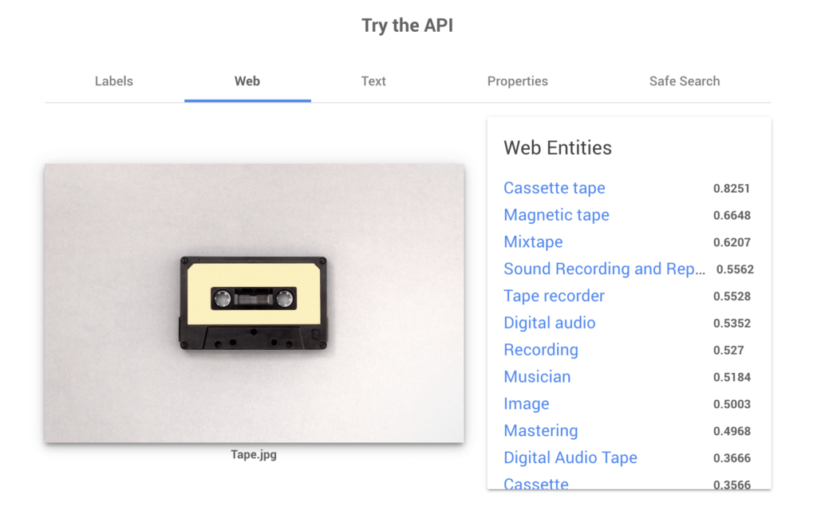

*Figure 2.3.1.1 Google Cloud Vision API (Simpson, J. 2020)*

The Google’s CloudVision API is almost like a plug-and-play type of image recognition API. It is already pre-configured to perform common image recognition tasks such as detecting explicit contents or object recognition. This system also takes advantage on Google’s extensive data and machine-learning libraries which makes it perfect on detecting landmarks and object identification in images which is the common use of this system. This system can also access information image in various ways and can return image entity identification, description, and matching images. Apart from that, it is also used to identify predominant color from images. The exciting feature from CloudVision API is the OCR recognition, it detects handwritten and printed text from PDF, images, or even TIFF files. The only downside about Google’s CloudVision API is that it is costly.

### 2.3.2 Imagga

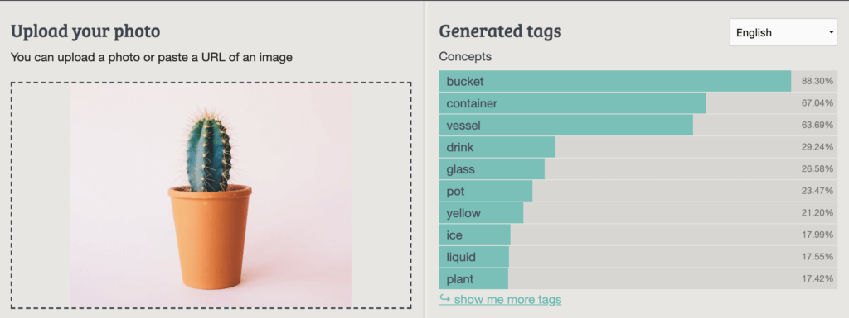

*Figure 2.3.2.1 Imagga identification and auto tagging (Simpson, J. 2020)*

Imagga API is known as an automated image categorization and tagging API that help deals with quantity of media. This system is categorized as a digital asset management API because it features an library asset that allows asset categorization and metadata management. This system also allows analytics and reporting and compared with other digital asset management such as Airtable, Box, or Canto Digital Asset Management, this system is the new digital asset management API on the block and it is also cheaper compared to the other options.

## 2.3.3 Microsoft Image Processing API

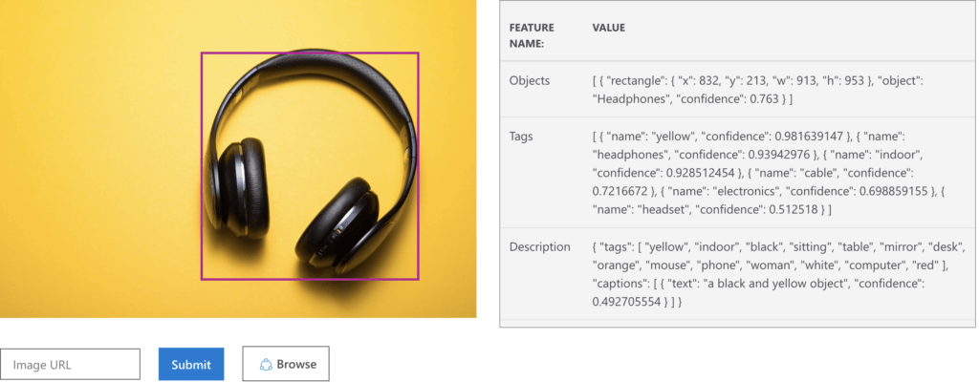

*Figure 2.3.3.1 Microsoft Azure Image Processing API (Simpson, J. 2020)*

Microsoft Azure Cloud’s Computer Vision API is unlike most API, it offers several of the same image recognition tools, and some innovative features. Image properties definition can assess the dominant hue of an image even if it is in black and white. The image categorization and content description describe image as a complete sentence as well as categorizing the content. The downside of this image processing system is that it is not free but not as expensive as CloudVision API.

## 2.4 Summary

Based on the literature review done, it is safe to say that there are various ways of doing image identification and recognition through machine learning. There are also various factors to consider before choosing the right machine learning such as the volume and type of dataset, type of output, computational time, number of features and observations in the data, and many other. With the research domain and system similarity done, It is safe to say that this project is deeply understood alone with a proper idea on how the system will be created to avoid issues.

# **Chapter 3: Technical Research**

In this section, technical research will be based on the proposed project. The discussion will include the details of programming languages used, tools, operating system, and few other alone with justification to support the decision of the selected choices.

## 3.1 Programming Languages

In this project, there are two important parts to develop a web application system, which are the frontend and the backend. Therefore, the two programming languages that will be used are JavaScript to develop the user interface, and Python to develop the machine learning model. Despite setting on the programming languages, a comparative analysis will be provided to support choosing JavaScript for user interface and Python to develop the machine learning model.

### 3.1.1 JavaScript and Python

JavaScript is a known and popular frontend open-source programming language that creates user-friendly and interactive frontend applications. Over the recent years, it has evolved into a dynamic, multi-paradigm, and high-level language. It is also a popular language that is used for clouds, browsers, server, containers, mobile devices, and microcontrollers. In web development, JavaScript is known to have a stronghold in the web development sector. It also provides event-driven programming with the help of node.js which is known as the ideal for head of input and output processes. Apart from that, the best part of it is that JavaScript practically works on all platforms (Navone, E. 2021). JavaScript is also much faster due to its lightweight and interpreting, and it is also integrated with HyperText Markup Language (HTML) which makes web applications to be easily implemented. Python is used in developing machine learning model due to the libraries feature with large amount of pre-written code and because of this, developers need not waste time creating basic items. These libraries allow developers to transform and handle data needed for continuous data processing in machine learning (Business. 2019). With Python in the web development, it is easier due to the object-oriented programming which is a paradigm that organizes different properties and behaviors into objects and classes. This consumes less time and costs.

## 3.2 Integrated Development Environment (IDE)

The integrated development environment is a software acts as a text editor, compiler, and debugger all in one. It is designed to make developers code easier. IDE is an application that facilitates application development and provides a central interface featuring the tools such as code editor which designed to write, edit codes, and makes it cleaner and more readable. The tool also includes compiler that transform codes written into computerized readable form, and a debugger which helps eliminate errors from programs for the code to execute and perform as it should (Nyakundi, H. 2021).

### 3.2.1 Visual Studio Code

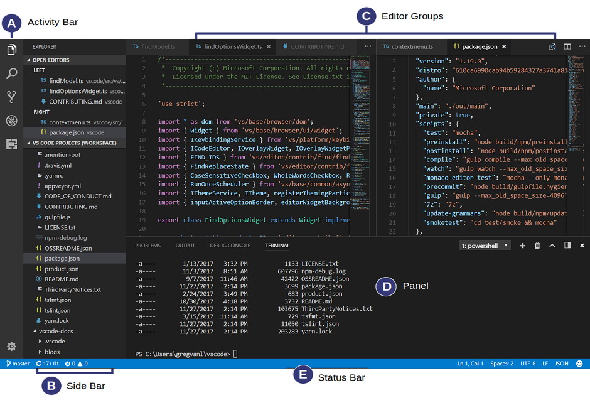

*Figure 3.2.1.1 Visual Studio Code User Interface (Bhatt, A. 2021)*

Visual studio code was made by Microsoft for Windows, MacOS, and Linux. It is also a source code-editor. Visual studio code does not come with compilers, intelligence, interpreters, and several other features that Visual studio has. However, Visual studio code can install extensions to extend its functionality and features. Instead of wasting much more memory space in device, only the extensions that are necessary for the projects will be installed. Visual studio code is also the perfect tool for web development, it comes with inbuilt support for Node.js development along with JavaScript and TypeScript. It is also lightweight in terms of resources due to the consumption of random-access memory (RAM) and processor usage (Bhatt, A. 2021).

### 3.2.2 Jupyter Notebook

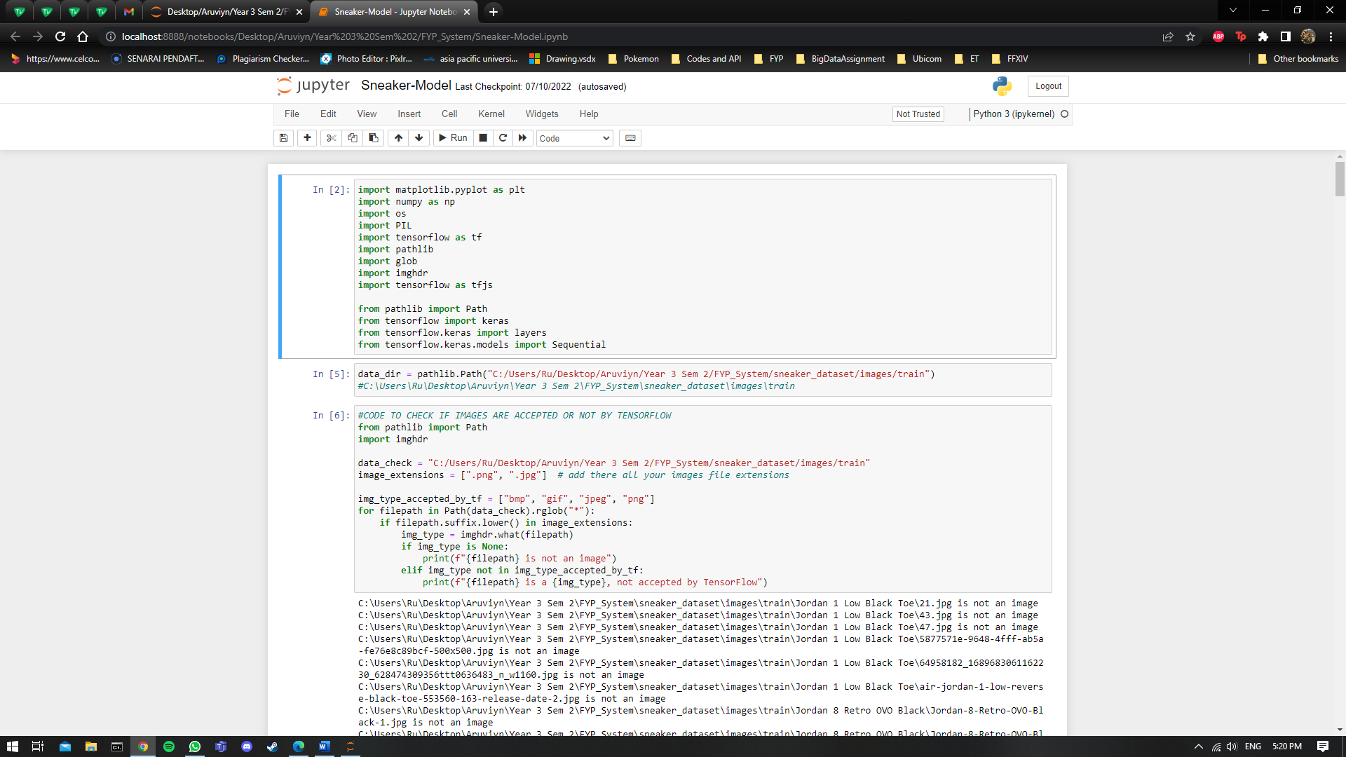

*Figure 3.2.2.1 Jupyter Notebook (Self-capture, 2022)*

Jupyter Notebook is a web application, or also known as an open-source IDE, which have computer rich text elements such as equations, paragraphs, links, figures, and some several others, and python. This IDE is essential for visualization and data analysis. The reason why Jupyter Notebook is used is because it allows illustration of analysis process step by step and allowing to document the thought process while developing the analysis process (Maynard-Reid, M. 2018).

## 3.3 Libraries and Tools

In programming languages, libraries are collections of precompiled and non-volatile codes that developers or programmers can use to optimize their tasks. Libraries are known as modules at times. It is stored in the format of objects. It is useful for storing frequently or commonly used routines so that developers do not need to link libraries to the program every time it is needed. A linker will automatically look in for libraries for routines that is not found anywhere else (Beal, V. 2021). To complete this project successfully, one library will be used which is TensorFlow. More libraries will be used and discussed in Chapter 9 Implementation.

### 3.3.3 TensorFlow.js

TensorFlow.js was developed by Google for training and using machine learning models in browser. It is a JavaScript library, and a companion library to TensorFlow which is a popular machine learning library for Python (Gubler, B. 2019). TensorFlow.js has good performance due the usage of WebGL which is the browser interface to OpenGL. OpenGL is an API that is used for rendering 2D and 3D vector graphics. Another cool features about TensorFlow.js is that it can load pretrained models. Apart from that, TensorFlow.js enables JavaScript code to run on GPU. It also enables building deep neural network that can easily be integrated into existing or new web application and heavily based on Keras API (Schaffer, E. 2021).

## 3.4 Database Management System (DBMS).

A database management system is a software tool that allows manipulation, management, and retrieval of data from a database. It is just a computerized system that keeps data. Database management systems have been categorized according to their data types or structures. On a mainframe, there are various types of databases that can be used, such as network, relational, inverted list, and hierarchic. Database management system is an important component in the most system. For this project, two database management have been selected which are MySQL, and DB2.

### 3.4.1 Firebase Realtime Database

Firebase Realtime Database is a solution that stores data in cloud-based format and eases users to retrieve data across different devices. The phrase ‘Realtime’ defines those changes made to the data will automatically be reflected across all devices immediately. Traditional database causes applications to become unresponsive when there is lose of connection. However, with Realtime Database, an internal cache of all ongoing data is contained although there is loss of network connection. The database also stores data in JSON format with multiple nodes (Djermanović, D. 2022).

### 3.4.2 DB2

This DBMS is created by IBM, it is a database engine with NoSQL capabilities. DB2 is capable of reading XML and JSON files. DB2 has BLU acceleration, which is makes database engine works faster through a technology known as data skipping. The technology is designed to enhance the speed of system with more data than it could fit into the memory. DB2 also possess disaster recovery functions, analytics, and compatibility. The DB2 can be hosted from a physical server or cloud, or both at the same time. By using Tasks scheduler, multiple tasks can be done at once. The downside of DB2 is that it is costly for most individuals, support is only available for three years, and to make multiple secondary nodes or clusters, an additional software or third-party tools is required (Arsenault, C. 2017).

### 3.4.3 Comparative Analysis Justification.

Upon reviewing the differences between Firebase Realtime Database and DB2, it is undeniable that Firebase Realtime Database is a better choice. Firebase Realtime Database is a free and it is commonly used among web-based application developers whereas DB2 is costly. Even though DB2 may be faster with a large amount of data, Firebase Realtime Database stores data in cloud-based format and syncs data across different devices. Therefore, for this project, Firebase Realtime Database will be used as its database management system.

## 3.5 Operating System

The operating system that will be used for the proposed project development will be the Microsoft’s Windows 10 Home Edition. For this part of the report, there are no justification or comparison to be done due to possession of only one device with Windows 10 operating system. As for the completion of the project, the system can run on any operating system and devices such as on laptop, desktop and mobile providing there is a web-browser in the device.

## 3.6 Web Server

Web server is used to deliver and store the website content. The contents may be in the form of texts, images, videos, application data, and many other as per request of the client. When a link or button is pressed on the displayed browser, it enquires data from the website (Upadhyay, I. 2020). As for this project, the web server that will be used is the NGINX web server. It is an open-source web server which now can be used as a HTTP cache, reverse proxy, and load balancer. It is considered as one of the most reliable web servers for its scalability and speed. Because of its ability to handle huge number of connections and speed, there has been many high-traffic websites that are using NGINX’s service such as Netflix, Adobe, Google, WorkPress.com, Cloudflare, and many other more (Domantas, G. 2022).

## 3.7 Web Browser

Web browser, in another name it is known as internet browser or just browser that is a software application which allows access to the world wide web. For this project, Google Chrome will be used. It is one of the best browsers there is in terms of feature compatibility, highly populated, enables integration with the Google ecosystem, and has excellent DevTools (Sokhach, D. 2022).

## 3.8 Summary

At the end of this technical research, the chosen programming language which have been compared and discussed will be the JavaScript for frontend and Node.js for backend in this project. Windows 10 will be used as the operating system on developing the project. The project can be deployed into any operating system at devices such as laptop, desktop, and mobile phone. Apart from that, the IDE that will be most suitable for this project is Visual Studio Code. Libraries that will be used for this project are Vue, Puppeteer, and TensorFlow.js. As for the database management system, after the discussion of each DBMS and comparison, a conclusion has come to use MySQL DBMS. NGINX webserver will also be used, and the most suitable web browser for this project development is Google Chrome. All in all, the technical research has been properly discussed, justified, and compared.

### 3.8.1 Justification of Changes in Summary

The changes in the summary discussed above will be the language chose which is Node.js to python for the backend of this system, The IDE used for this project which includes Jupyter Notebook for the machine learning model, libraries used which includes TensorFlow and Keras along with the removal of Vue and Puppeteer, and the usage of DBMS which will be none. The changes done for this system is due to the lack of knowledge and time in certain areas. With these changes, the system will be fully functional with no errors.

# **Chapter 4: System Development Methodology**

In software engineering, a system development methodology is a framework that is used to plan, control, and structure the process of developing an information system. The system development methodology is required to ensure a successful implementation a system. The system development life cycle (SDLC) is a standard approach for managing phases of a project. There are several phases of SDLC which are discussed below.

* Planning
  + During the planning phase, project leaders will have to evaluate the project terms. Which includes the costs of material, labor, timetable, goal, leadership structure, and creating the project teams.
* Defining requirements
  + Defining the resources needed for the project. Determining on what problem the software is solving and obtaining lists of requirements for better understanding of the application.
* Design and Prototyping
  + Creating an early version or a prototype of software in the iterative software development model. Purpose is to demonstrate a general or basic idea of how the system or application supposed to look or work.
* Software Development
  + In this phase, code of the program will be written. If the scale of the project is a small one, a single developer may be sufficient, but for a larger project, there will be several teams working together, making sure that each team’s code are compatible with the others.
* Testing
  + Before deployment of the application to the client, tests will be done to fix bugs or glitches that may be present in the system. Once everything is fixed and ready, the team may proceed to the next phase.
* Deployment
  + Once the application is fully functional, it will be available for the user to use the application.
* Operations and Maintenance
  + At the final phase of the system development life cycle, the application is already done, and it is being used by the user. When users discover errors, glitches, or bugs, it needs to be resolved which may require a new system development lifecycle.

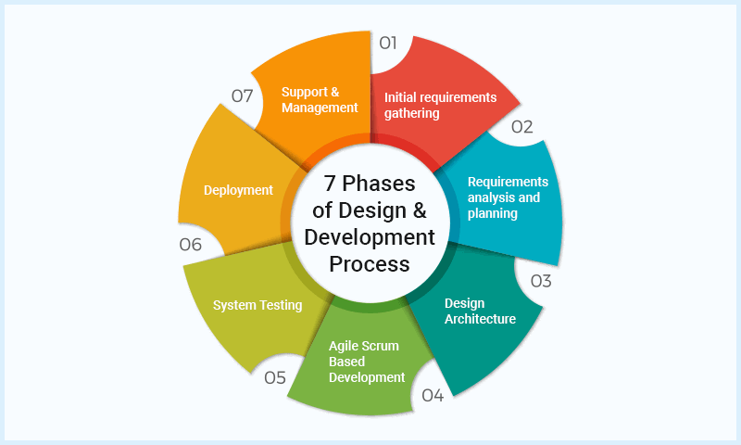

*Figure 4.1.1.1 Visual Representation Of SDLC (Gray, S. n.d.)*

For this project, two system development methodology have been identified, which are waterfall and Rapid Application Development (RAD).

## 4.1.1 Waterfall Methodology

Waterfall methodology is one of the oldest, and popular software development methodologies. It proceeds in a single linear direction, in which a phase must be completed before proceeding to the next phase. There is a total of seven stages in this methodology, whereby each stage is completely dependent on the previous stage, and it is unable to overlap with other stages. To advance to the next stage, the current stage must be completed, reviewed, and approved. It is a tight structure that ensures efficiency. Below are the five stages of waterfall (Sharma, K. 2020)

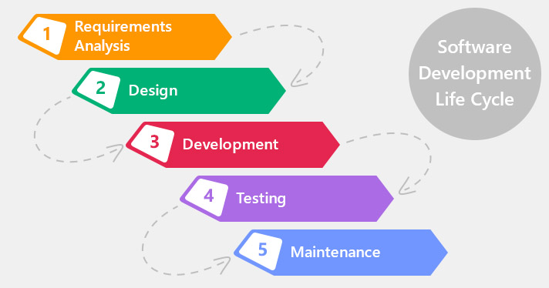

*Figure 4.1.1.1.1 Illustration of waterfall phases (Lvivity. 2018)*

* **Requirement Analysis**: It is an important phase where all the requirements are gathered from the client at the very beginning of the project. This allows proper planning for other phases without association with the client until the project is completed (ProjectManager, n.d.).
* **Design:** A technical solution is to be designed to counter problems that set out by the product requirement, layouts, data models, and including scenarios. In this phase, it is an idea of how the product would look like at the end. It is usually accompanied with documentation for all the requirements which allows team members to review for validation purpose (MaRS, n.d.).
* **Implementation:** Once the design has been approved, the technical part begins. Implementation phase is when the team starts coding the application based on client’s requirement and previous documentations (ProjectManager, n.d.).
* **Testing:** Upon completion of the code implementation, tests are performed to ensure no further errors before application is released to client. There are several tests that can be done, the common test that is normally done is the user acceptance test where client or user tries the application before releasing it (Smartsheet. n.d.).
* **Maintenance:** This is the last phase where the application has already been released to the client. The client would regularly use the application and report back it a bug or error is discovered. The team must fix the necessary errors until client is satisfied.

### 4.1.2 Rapid Application Development (RAD)

The RAD methodology is a form of Agile software development methodology that prioritizes rapid prototype iterations and releases. Unlike Waterfall methodology, RAD emphasizes usage of software and user feedback over requirements recording and strict plannings. Below are the phases of the RAD methodology.

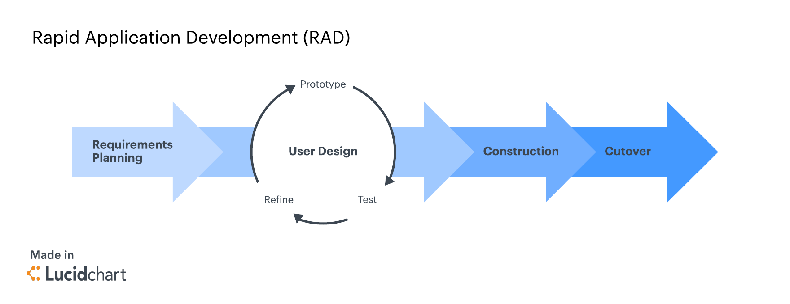

*Figure 4.1.2.1 Illustration of Rapid Application Development (Lucidchart, n.d.)*

* **Requirements Planning:** At this phase, developers and clients communicate to understand the goal, expectations, current and potential issues that needed to be address during the build. The first phase is the critical step for success of the project. Discussion will breakdown based on researching current problem, requirements defined for project, and finalizing requirements with stakeholders’ approval. Through the approval of stakeholder, the team can avoid costly changes and miscommunication (Lucidchart, n.d.).
* **User Design / Prototype:** Once the first phases has been cleared, the team will proceed with prototyping by building the initial models. RAD methodology is to rapidly produce a design that is working to be demonstrated to the client. Through the rapid production of prototype, it encourages user testing and feedback on a live system. It also allows stakeholders to learn through experience with the prototype. Errors are likely to be discovered at this stage which may lead to reduction of errors and bugs at the end phase (Chien, C. 2020).
* **Rapid Construction and Feedback Gathering:** During this phase, the developers will be coding the application, system testing, converting prototype, unit integration occurs, and beta system into a working model. In RAD, it is normal for team to use rapid application development tools or low code to quickly progress the application. Upon completion, the client will test the software and applications ensuring that it is a satisfactory result which meets clients’ objectives and expectations. Clients are also to give their input and feedbacks on this stage. With further inputs or feedback from client, developers will resume the prototyping, or when the client is satisfied with the progress, team will move on to the final phase (Chien, C. 2020).
* **Finalize Product / Implementation:** At the final phase, developers will tend to the technical errors that occurred during the prototyping, optimizes implementation for improvement, stability, and maintainability. Once that is done, the full-scale testing will be conducted to identify bugs in the system. The team then releases the application for public for necessary testing. The team will then write their documentation and complete necessary tasks, before handing client the product confidently (Chien, C. 2020).

### 4.1.3 Comparative Analysis between Waterfall Methodology and RAD Methodology.

|  |  |  |
| --- | --- | --- |
| Project Properties | Waterfall | RAD |
| Time | Follows schedule, if significant changes must be made, it is required to start the project from the beginning. | Open-eded, it is considered done if the client is happy. |
| Ideal Size | Small to large projects | Small to medium projects |
| Developer Team | Can be a small to large number of people, would normally exceed 15 people due to strict on hierarchical. | Must consists of small amount of group members. |
| Project | On-premises or desktop application | Web-based or mobile applications |
| Risks | Check for potential risks at the beginning and account them, if risks emerge, it should not be prioritized or disrupt the project flow | Prepare and respond for risks continuously. |
| Change | Changes are seen as negative and will disrupt the project flow | Changes are welcomed and embraced |
| Time for Change | Only during first phase | Anytime |
| Management | Project manager must ensure the team sticks to the original plan | Project manager style is adaptive |
| Features | Every feature in the specification is built | Only features that are useful will be built. |
| Costs | Costs are fixed assuming there are no changes that cause the project to return. | Variable, depending on the number of iterations |
| Prototype | Prototype are delivered after the entire app is fully functional | Working model are delivered as soon as possible for more feedback and optimization. |

Table 4.3.1. Comparative analysis between Waterfall and RAD methodology

## 4.2 Justification

Based on the comparative analysis shown in table 4.3.1, It would prove that for the proposed project will be well suited with waterfall methodology. This is because, it is much safer following through step by step and not repeating the previous step. With this, confusion can be avoided, especially when working on a project alone. Therefore, rather than using the RAD methodology which rapidly completes the prototype, having a proper procedure flow would be much recommended for this proposed project.

## 4.3 Overview of Project

The project Sneaker identification and recognition is perfect for the waterfall methodology. To ensure a successful system without errors, the five phases of waterfall must be followed. The phases help in preventing confusions and errors to the system.

* **Requirement Analysis:** During this phase, it is important to gather all the requirements of the proposed system at the beginning for smooth planning for the phases ahead. The project scope must be determining the goal with building the system, such as functional requirements, features, deliverables and so on.
* **Design:** The requirements of the proposed system should be clear during this phase. Based on the information obtained from the first phase, the hardware and software requirements along with the system architecture must be determined for this project. This can be done through two methods. The first at which is the collect tasks. A work breakdown structure to list all tasks that are necessary to achieve final deliverable and create a schedule to estimate time of each task will take. From there, a Gantt Chart will be mapped out.
* **Implementation:** In this phase, the proposed programming language, IDE, Libraries, and the other technical research from Chapter 3 will be used here to build the system.
* **Testing:** The application system will be built and tested in this phase. The system from previous phases is first developed in smaller program called units, and each of the unit goes through testing processes before being integrated. A few target users will be selected for user testing purpose as well. Once the tests are done, it is ready for deployment.
* **Maintenance:** Upon deploying the system, information such as issues from feedback will be collected for fixing and further improvements of the system.

# **Chapter 5: Research Methods**

## 5.1 Introduction

Research methods are techniques, processes, or strategies that is utilized in collecting data or evidence for an analysis to discover new information or create a better understanding of a topic. Research is defined as careful consideration of study on a certain concern or problem through scientific method. There are many techniques and methods used to conduct research methodology. The research procedure will enhance the process and exposes the way it was carried out. Research methods can be classified based on different criteria. It is a nature of study, general category, purpose of the study, and research design. There is research that uses more than two methods combined whereas there are also some that takes very few methods into account of study (Pedamkar, P. n.d).

* **Quantitative Research Method:** Quantitative research is the procedure of analyzing and collecting numerical data. It is used to gather mostly close-ended questions. Numerical data can be used to find averages and patterns, test causal relationships, make predictions, and generalize results to wider populations. In other words, it also discovers the findings of how many, how often, to what extent, or how much. Quantitative research is commonly used in social science like chemistry, biology, economics, sociology, marketing, etc (Bhandari, P. 2020).
* **Qualitative Research Method:** Qualitative research is the exact opposite of quantitative research which involves the analyzing and collection of non-numerical data. It is mostly used on gathering open-ended questions. It gathers data on lived experiences, behaviors or emotions, and the meanings individual attach to them. It helps in having researchers to gain more understanding of complicated concepts, cultural phenomena, or social interactions (Bhandari, P. 2020).
* **Mixed Research Method:** The mixed research method is the combination of both quantitative and qualitative research which involves in collecting both open-ended and closed-ended data. It gives a holistic approach analyzing and combining the statistical data with deeper insights. The mixed method also allows verification, or triangulation of data from two or more resources.

As for the proposed sneaker identification and recognition system, the research method used to gather data is by using the mixed research methodology which consists of both close-ended and open-ended questions through questionnaires. The reason of choosing questionnaires is because it is fast and easy at gathering large volume of data, and efficient. Especially during these COVID-19 pandemic times, it is much easier and healthier to collect data through questionnaire than other methods. other methods. Questionnaires was done through Google Form, the tool used is particularly effective for measuring preference, intentions, subject behavior, attitudes, and opinions. Questionnaires enables comprehensive results to be obtained. The purpose of the data gather for this system is to further understand the needs of respondents, the system, and for further enhancements of the system. Although there are disadvantages in questionnaires, but due to the large volume of data obtained, it is sufficient to overcome the dishonesty answers given by respondents.

## 5.2 Questionnaire

As mentioned above, for the proposed system, questionnaire will be used to collect data. The Sneaker identification and recognition system requires large number of respondents to further understand the need of the system, users, and further improvement on the system. Through questionnaire, data can be collected relatively quickly. This is because researcher is not required to be present while respondent is completing the questionnaire. Questionnaires are often both open and closed ended questions to collect both quantitative and qualitative data. However, there are advantages and disadvantages of using questionnaire.

* **Advantages:**
  + It is cost-efficient, researcher does not need to spend much to delivery the survey questions to the respondent. In fact, researchers may email respondents the survey questions which bares no costs.
  + It is time efficient; survey results are quick and effortless using tools.
  + Questionnaires online often have built-in tools that helps analysis, making it easier and faster to interpret results from respondents.
  + Respondents may be more comfortable staying anonymous and are not subjected to stressful time constraints, helping them feel at ease while doing the survey and encouraging them to provide honest responses.
* **Disadvantages:** 
  + Respondents may not answer the survey questions honestly. Some may even have hidden agenda to sabotage.
  + Some respondents may even have hard time interpreting questions which are not straight forward enough, which makes them struggle and forces them to provide answers that are not honest.
  + When a questionnaire is too long, respondents may feel fatigue of answering way too many questions in the survey.

## 5.3 Questionnaire Design

The questionnaire for the proposed system will be done on Google Form, which consists of 16 questions. Out of 16 questions, 4 of it are open-ended questions and 12 are close-ended questions. The aim of this questionnaire is to have an understanding on how convenient and efficient the system having been implemented for users, understanding users needs, understanding features based on suggestions given, and for further improvement on the system. As a safety precaution while handing out the survey form, there will be a consent form for users who wish to participate. Apart from that, an introduction will also be given about the system on the first page of the survey form. The data obtained from this questionnaire will be analyzed and further discussed on Chapter 6 of this report.

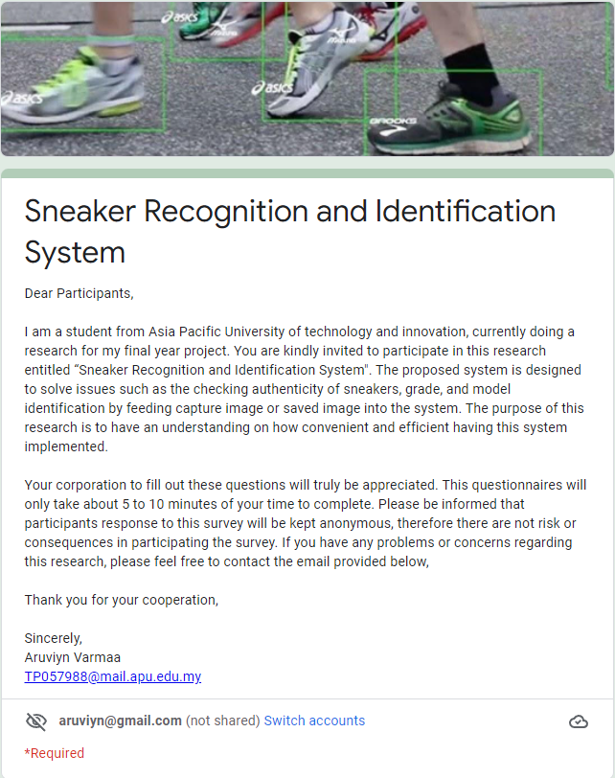

*Figure 5.3.1 Introduction of system on survey form.*

The purpose of this introduction is to inform respondents about the problem context on the proposed system, and its features. From the introduction, respondents have been informed that this survey will used for academic purposes only. Respondents who are willing to cooperate by participating may do so after reading the introduction.

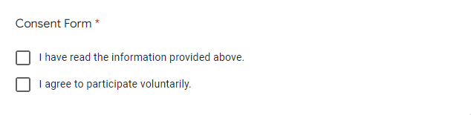

*Figure 5.3.2 Consent Form.*

Respondent who wishes to continue participating in the survey form must agree to select the check box to proceed.

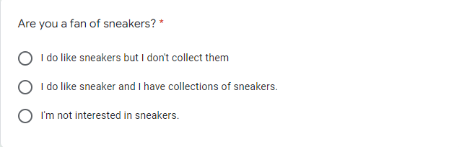

*Figure 5.3.3 Question 1*

The objective of this question is to identify if respondent is a fan of sneaker or not. Based on their answer, it will lead the survey page into different pages with different questions being asked for more data.

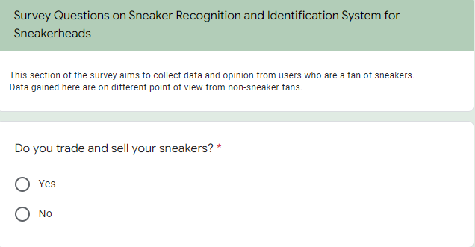

*Figure 5.3.4 Question 2A*

Respondents who answered the first and second choice from figure 5.3.3 will be led to the second page of people who likes sneaker with a different set of questions. The question in figure 5.3.4 is to determine if trade and sell their own sneaker. The objective of this question is to determine if respondents are actively dealing with sneakers.



*Figure 5.3.5 Question 3A*

The objective of question 3 shown in figure 5.3.5 is to determine respondents trust on sneakers upon purchasing counterfeit sneakers. Respondents who answered “Yes” will be able to look forward for the proposed system.

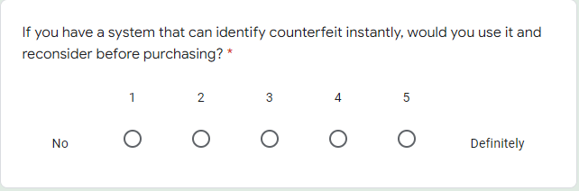

*Figure 5.3.6 Question 4A*

The objective of this question is to determine if the proposed system can be used to help people in the future. Ideally participants who have such a system should answer 5 because it really helps in the fear of purchasing counterfeit products.

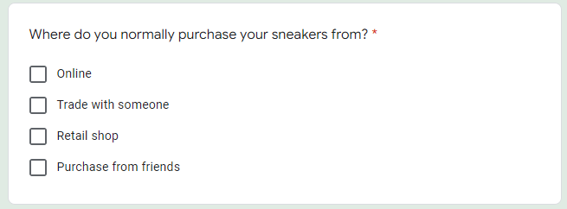

*Figure 5.3.7 Question 5A*

The objective on question 5 is to determine where respondents would normally purchase their sneakers from. With the help of the proposed system, purchasing online, trading with someone, or even purchasing from a friend, may encounter a counterfeit product instead of the original ones.

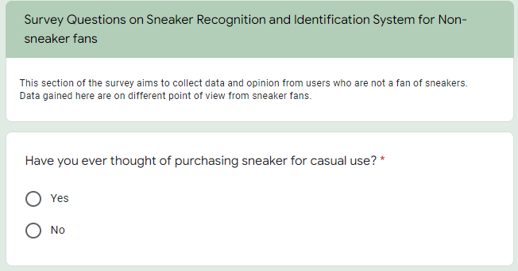

*Figure 5.3.8 Question 2B*

From respondents who answered no interest in sneaker in figure 5.3.3, respondents will be led to a different page with a different set of questions. The objective of question 2 above is to determine if a person with no interest in sneaker would purchase one for casual use.

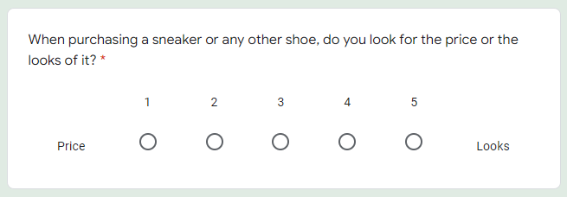

*Figure 5.3.9 Question 3B*

The objective of question 3 is to determine the if the respondent is into sneakers despite answering no interest in figure 5.3.3. Respondent who answered 5 in this survey question may be a potential user of the proposed system.

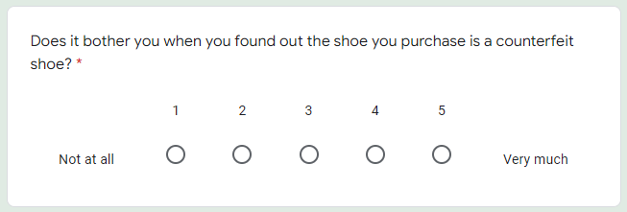

*Figure 5.3.10 Question 4B*

The objective of this question is to determine if respondents are bothered by unknowingly purchased a counterfeit shoe and finds out later. Respondents who have answered 5 are a great potential of a user for the proposed system.

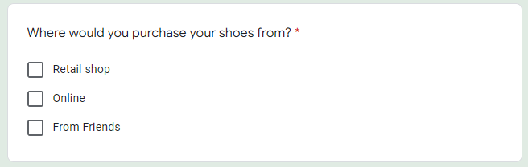

*Figure 5.3.11 Question 5B*

Like figure 5.3.7, the objective of this question is to determine where respondents would normally purchase their shoes from. Respondents who have no interest may not have the fear of purchasing counterfeit shoes.

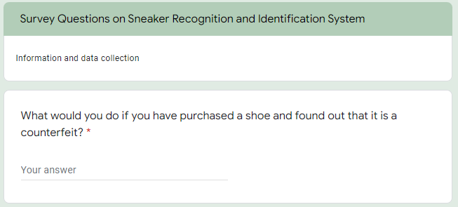

*Figure 5.3.12 Question 6*

The question 6 above is an open-ended question where respondents can freely provide any answer they wish. The objective of this question is to determine if respondents are troubled after purchasing a counterfeit sneaker since counterfeits are a problem in the footwear industry.

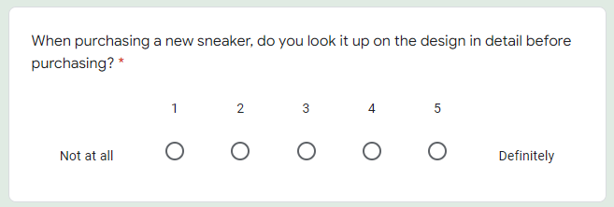

*Figure 5.3.13 Question 7*

The objective of question 7 is to determine if respondent checks carefully on the product before purchasing or not. Respondents who do not check the products in detail may not have a chance of identifying if the product is a counterfeit made.

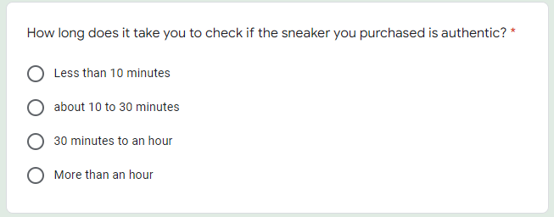

*Figure 5.3.14 Question 8*

The objective of question 8 is to determine how much time a customer spends their time to look up on checking their product if it is authentic or not. Depending on the brand and model, it may take some time due to many shoes that has been produced and the variety of sources to check for one model are limited as well.

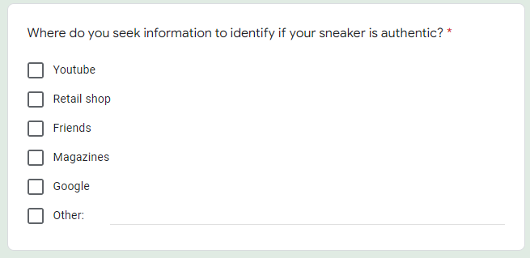

*Figure 5.3.15 Question 9*

The objective of question 9 is to determine the source of information customer uses to identify the authenticity of their sneaker. Sneaker may be a large industry but having each and every model around the, it is may is not easy to find the right source.

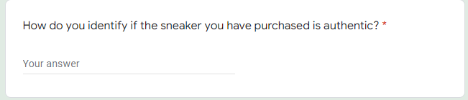

*Figure 5.3.16 Question 10*

The purpose of question 10 is to determine the methods customers would use right after purchasing a sneaker to check its authenticity.

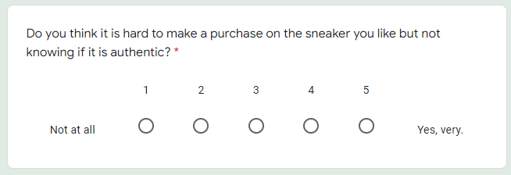

*Figure 5.3.17 Question 11*

The objective of question 11 is to determine the behavior and attitude respondents may show. Some may have confidence in purchasing without knowing if the product is authentic, some other may be afraid in purchasing before checking, and the rest would be neutral about it.

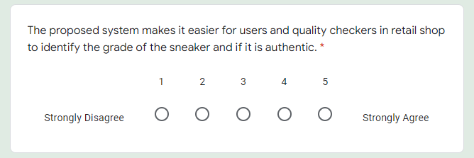

*Figure 5.3.18 Question 12*

The objective of question 12 is to determine if respondents are interested in the proposed system. Ideally most participants will be answering a strong 5 due to the counterfeit sneakers that are going around. The proposed system would help customers reduce purchasing counterfeit by mistake.

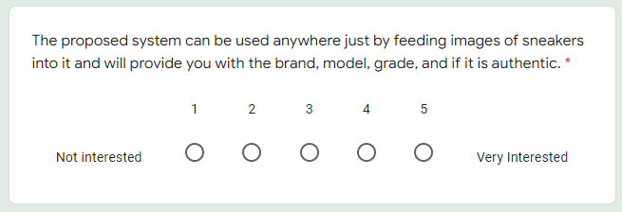

*Figure 5.3.19 Question 13*

The objective of question 13 is to determine the convenience of the feature from the proposed system where user are required to capture an image of a shoe and feed it into the system and it provides the output.

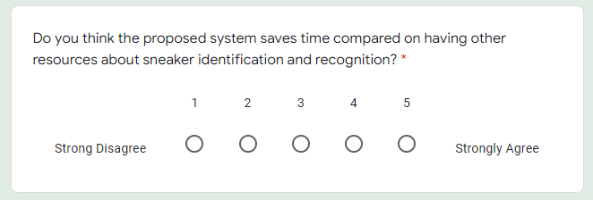

*Figure 5.3.20 Question 14*

The objective of question 14 is to determine if the proposed system would be more efficient than having user to search for an alternative way to identify if the sneaker is authentic or not.

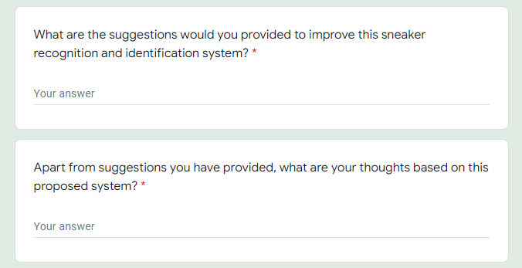

*Figure 5.3.21 Question 15 & 16*

The objective of both question 15 and 16 is to determine the respondents’ suggestions on the proposed system, as well as their thoughts on it. Based on their answer, the proposed system may be able to be enhanced.

## 5.4 Summary

Each of the research method used was discussed, and questionnaire was discussed. The questionnaire shown in section 5.3 was designed carefully to attract number of respondents. The number of questions designed was no large number of questions that would tire respondents. The qualitative and quantitative method was applied in the questionnaire with the open-ended and closed-ended questions and the objective of each question was discussed and explained. The data obtained through this questionnaire will be discussed and analyzed in the next chapter.

# **Chapter 6: Requirements Validation**

In this chapter, the data obtained through questionnaire will be analyzed. The questionnaire was designed to obtained various data from the respondents. The output of close-ended questions done by respondents will be in the form of pie chart and bar chart. Whereas the open-ended questions will be in the form of words in a table. The data analyzed will be used for the improvement of the proposed system and for future enhancement.

## 6.1 Analysis of Data Collected Through Questionnaire

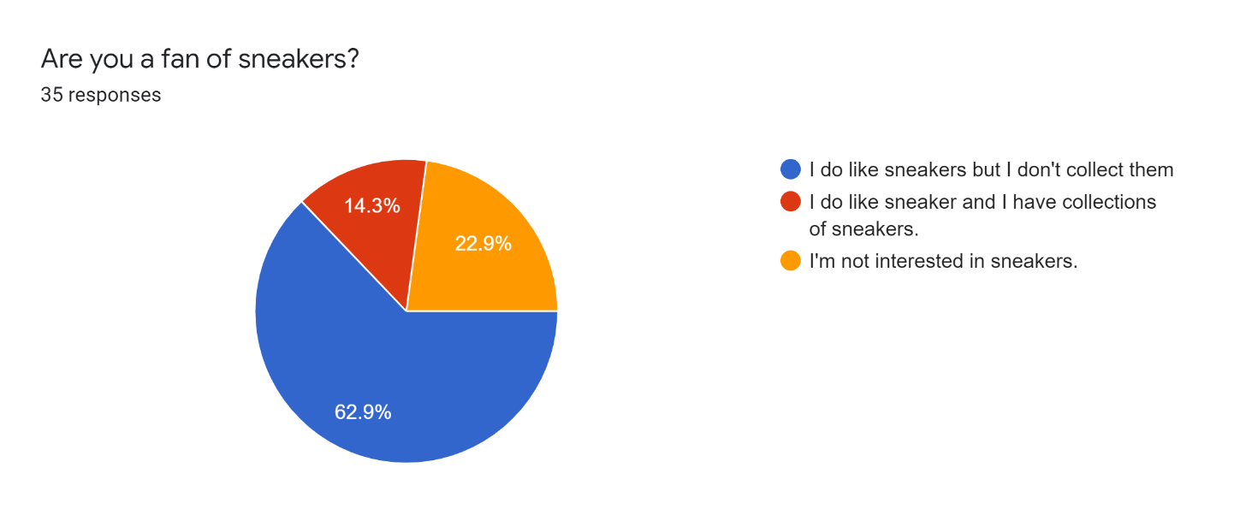

*Figure 6.1.1 Pie Chart of Question 1*

The figure 6.1.1, among all the respondents, there are 62.9% of respondents who likes sneaker but does not have collection, 14.3% likes sneaker and have collections of sneakers. And 22.9% who are not interest in sneakers. Based on the result shown above, It can be concluded that 22.9% of the respondents will not answer the same question as the other 77.1% for the next section.

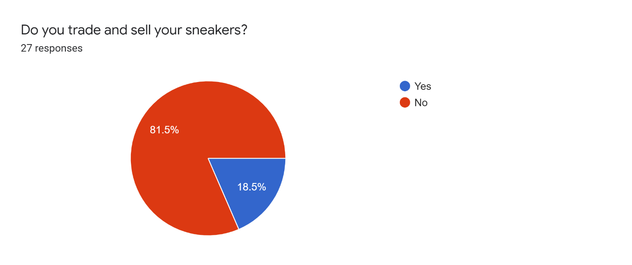

*Figure 6.1.2 Pie Chart Question 2A*

As shown in figure 6.1.2, the number of respondents who does trading and selling their own sneakers are 18.5% of the respondent and the other 81.5 does not. From here we can conclude that the 18.5% of the respondent are a part of the Sneakerhead community that often deal with sneakers.

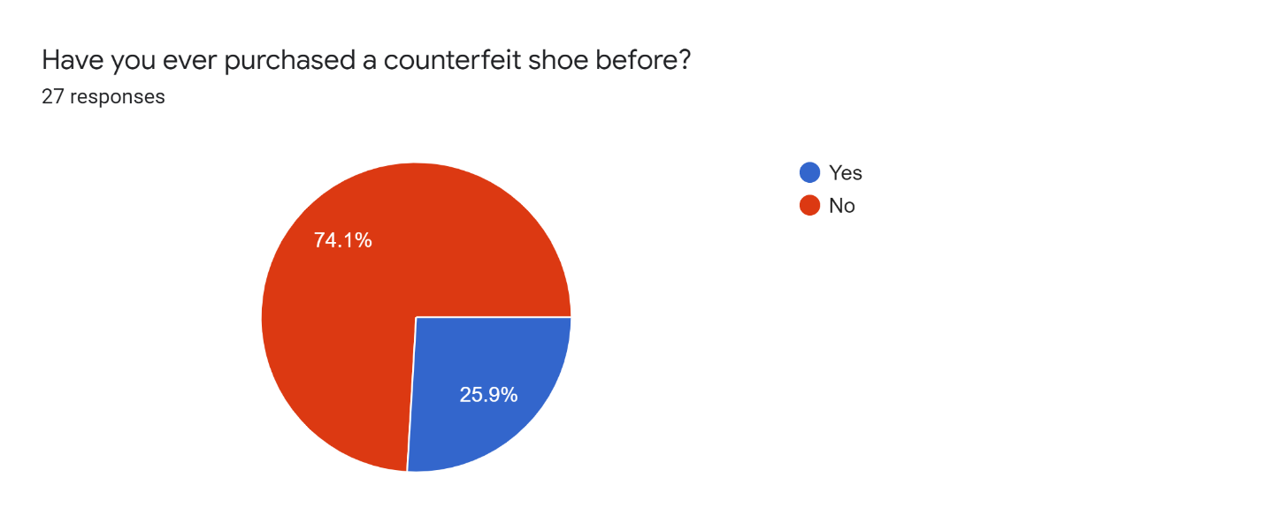

*Figure 6.1.3 Pie Chart Question 3A*

Figure 6.1.3 shoes that in question 3A, 25.9% of the respondents have willingly or unwillingly purchased a counterfeit shoe whereas, the rest of the 74.1% have not experienced it. Based on the result, among the 25.9% of the respondent who purchased a counterfeit sneaker unwillingly would understand the feeling of being tricker in the sneaker market.

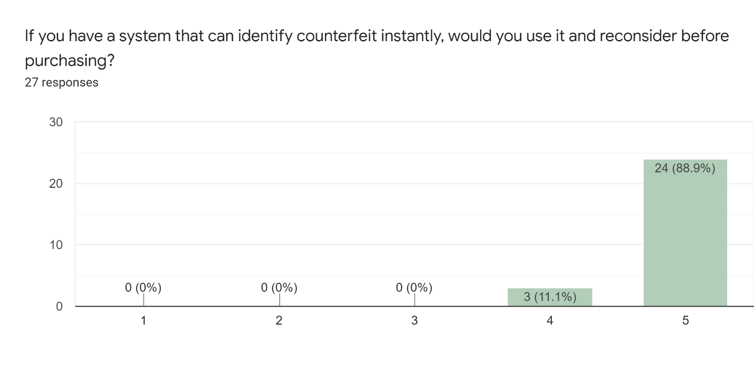

*Figure 6.1.4 Bar Chart Question 4A*

Based on the result shown in figure 6.1.4, there were 88.9% of respondent who would use the system that would identify counterfeit sneakers, and 11.1% would use the system. This shows how important the proposed system is to the users who likes sneakers. It would greatly benefit them in during their sneaker purchase.

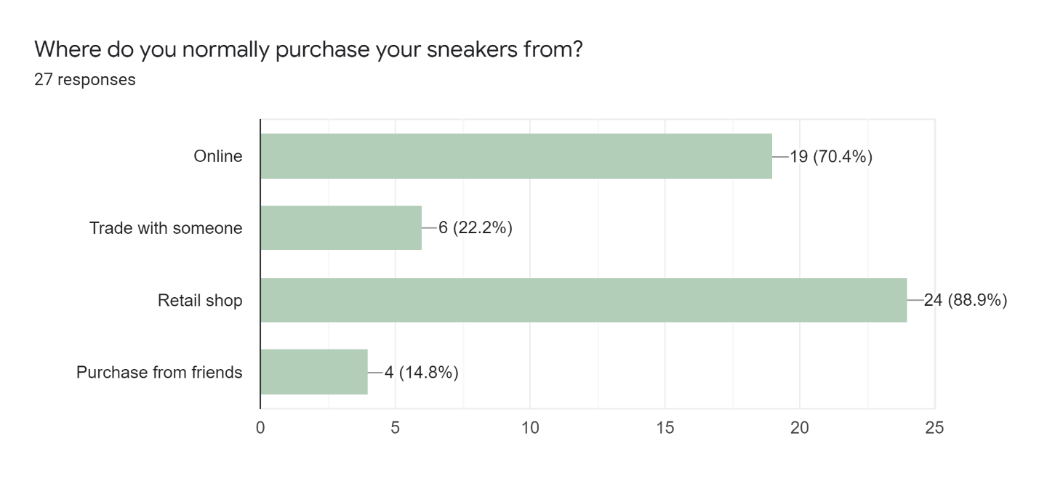

*Figure 6.1.5 Bar Chart Question 5A*

From the bar chart in figure 6.1.5, most of the responders rather purchase their sneaker in retail shops. The second most purchases were done online, and the third was through trading with others. Based on the bar chart in question 5A, purchasing in retail shop is much more convenient, due to rare counterfeit products being sold there. Not only respondents would purchase in retail shop because of the fear of counterfeit, but it is also convenient to get the right size in a retail shop instead of elsewhere.

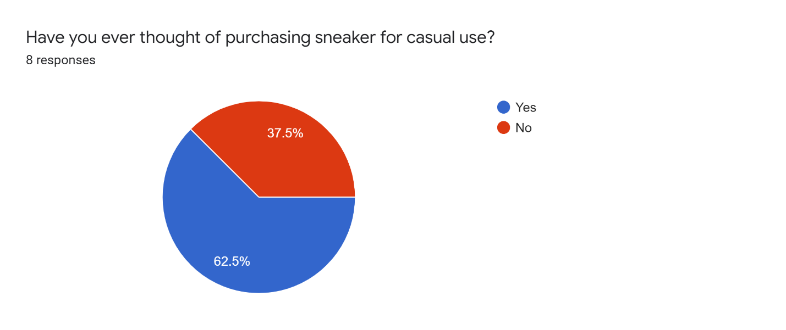

*Figure 6.1.6 Pie Chart Question 2B*

Based on the pie chart in figure 6.1.6, in the total of 8 respondent, there are 37.5% who does not purchase sneaker for casual use and 62.5% does. This concludes that in the section where respondent has no interest in sneakers, there are 37.5% of them that are not into sneakers.

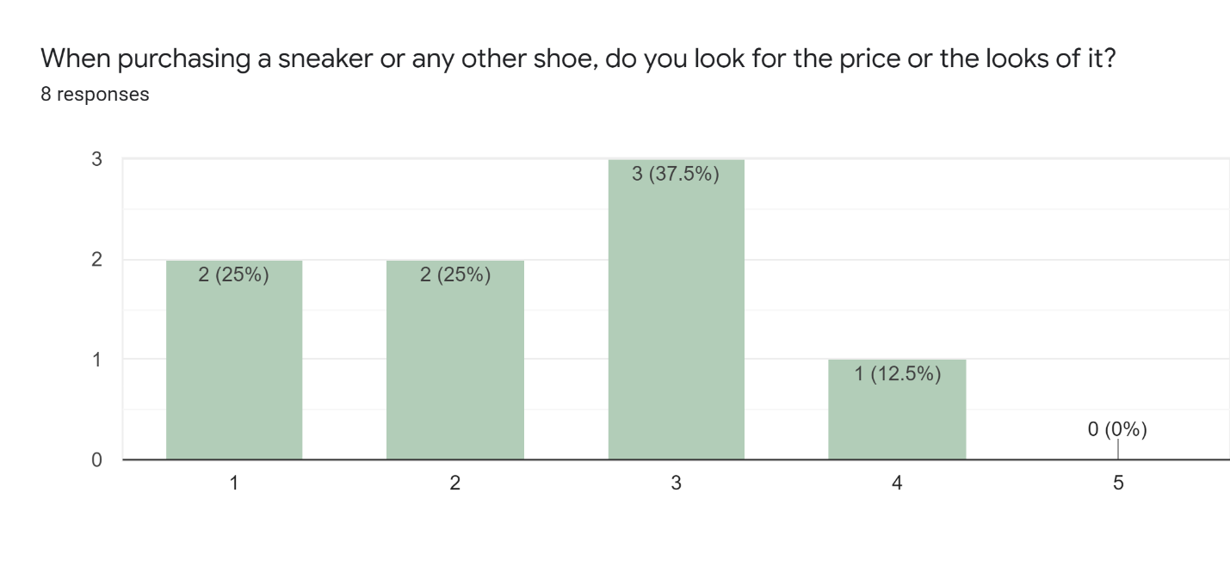

*Figure 6.1.7 Bar Chart Question 3B*

Figure 6.1.7 above shoes the bar chart of question 3B. Based on the bar chart, 37.5% of the respondent does not look at the price nor the looks of a sneaker while purchasing a sneaker, whereas 25% greatly looks at the price and the other 25% respondent also looks at the price. Only 12.5% of the respondent would go for the looks of a sneaker. It is determined that half of the respondents in the non-sneaker fan section would look at the price rather than the looks of a sneaker.

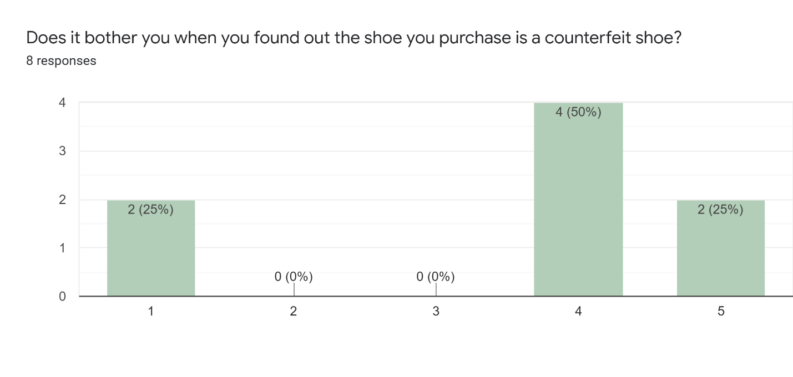

*Figure 6.1.8 Bar Chart Question 4B*

From the bar chart in figure 6.1.8, there are 50% respondent who are bothered by purchasing counterfeit shoes, 25% who are very bothered, and 25% who are not bothered at all. Most of the respondents are disturbed with the fact that they found out the shoe was a counterfeit only after they have purchased it. Even though that the respondent had no interest in sneakers, it still bothers them that the shoe they bought were a counterfeit.

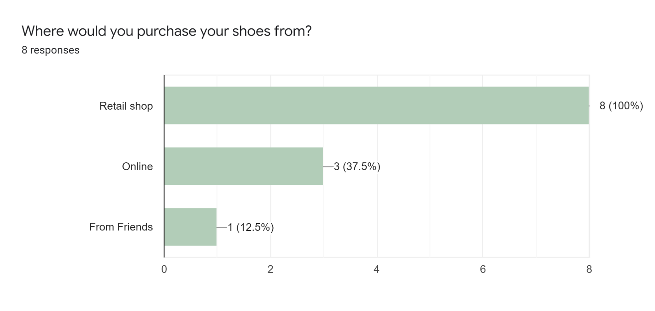

*Figure 6.1.9 Bar Chart Question 5B*

The last question for this section shown in figure 6.1.9, all the respondents would rather purchase their shoes from a retail shop, 37.5% would purchase it online, and 12.5% would purchase from friends. Figure 6.1.5 and figure 6.1.9, in both sections, respondents prefer buying shoes in the retail shop.

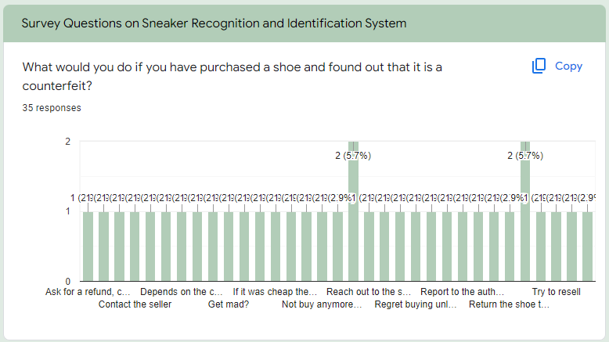

*Figure 6.1.10 Bar Chart Question 6*

The question on figure 6.1.10 was a open-ended question where respondents are free to provide any answers they wish. There are various answers provided by the respondents, but among every other answers provided by the respondents, 5.7% of them would reach out back to the person they bought it from, and another 5.7% would try to return it to the seller. This shows that there are various things that can be done once a customer has purchased a shoe and found out that it was a counterfeit.

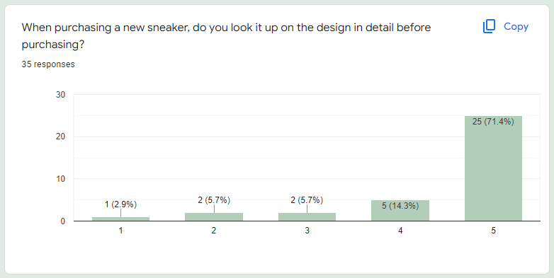

*Figure 6.1.11 Bar Chart Question 7*

Based on question 7 in the figure 6.1.11, 71.4% would strongly agree to check the design in detail before purchasing a sneaker, and 14.3% would agree to check the design detail before purchasing. The rest of the respondent would not check the design before purchasing a sneaker.

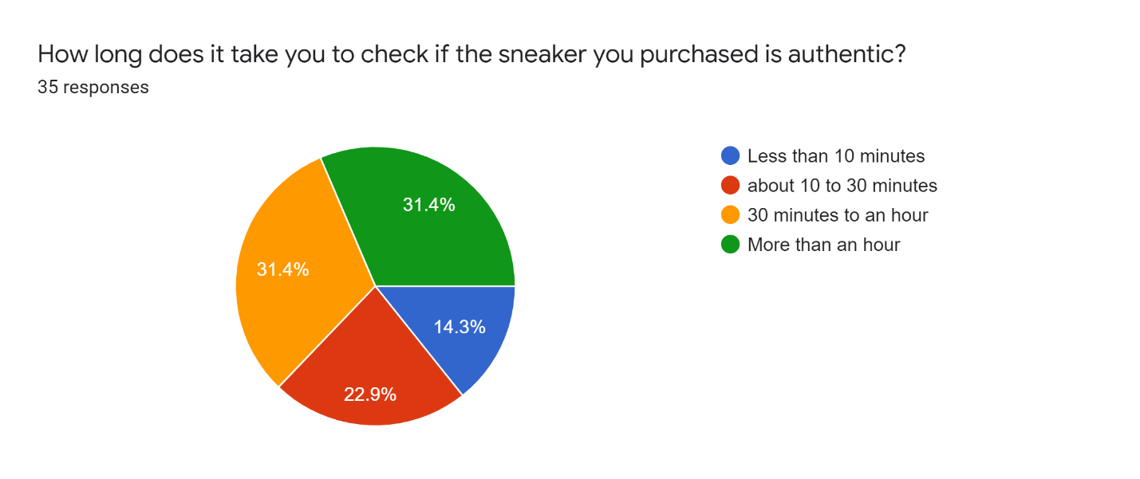

*Figure 6.1.12 Pie Chart Question 8*

Based on the pie chart on question 6.1.12, most of the respondent takes about from 30 minutes to an hour, and more than an hour to check if the sneaker purchased is authentic. There are 14.3% of the respondents took only less than 10 minutes to check the authenticity, and 22.9% takes from 10 to 30 minutes. The more the time is consumed, the more the purpose on using the proposed system.

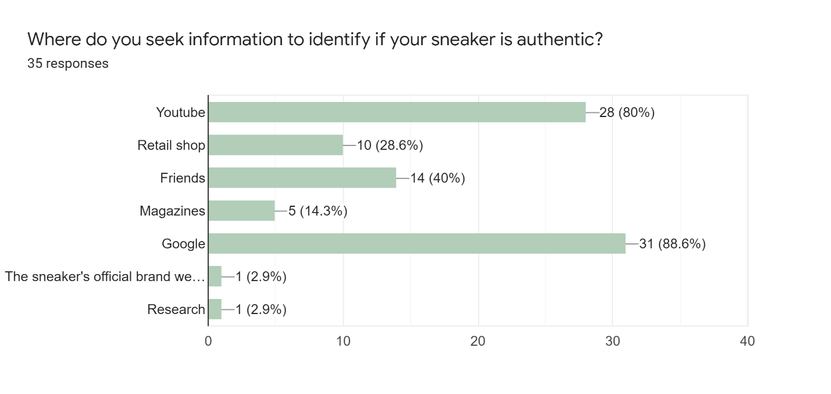

*Figure 6.1.13 Bar Chart Question 9*

The bar chart from question 9 shown in figure 6.1.13 is the methods on where respondents seek for information to check the authenticity of their sneaker. 88.6% would search on Google, 80% of them would view YouTube videos, 28.6% would go and clarify with retail shop, 40% would ask their friends, 14.3% would look through magazines to confirm the authenticity, 2.9% would do their own research, and another 2.9% would check on the sneaker’s official brand website. This question is the combination of both open-ended and closed-ended, respondents may select from the check box or provide their own answer. Most of the respondents would check on Google and YouTube to check the authenticity of their sneaker.

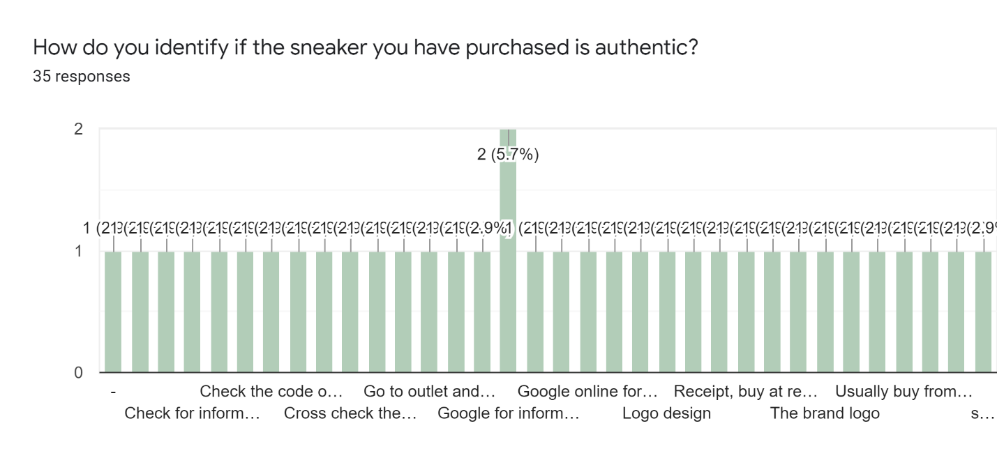

*Figure 6.1.14 Bar Chart Question 10*

Question 10 is an open-ended question where respondents are free to provide any answer. Based on the bar chart provided, there are various method on how respondents would identify the sneakers authenticity. Some would look onto the logo design or brand log, some would check based on the packaging and price, the correct pattern, and many other more. It is not easy to differentiate between a counterfeit sneaker and an original one.

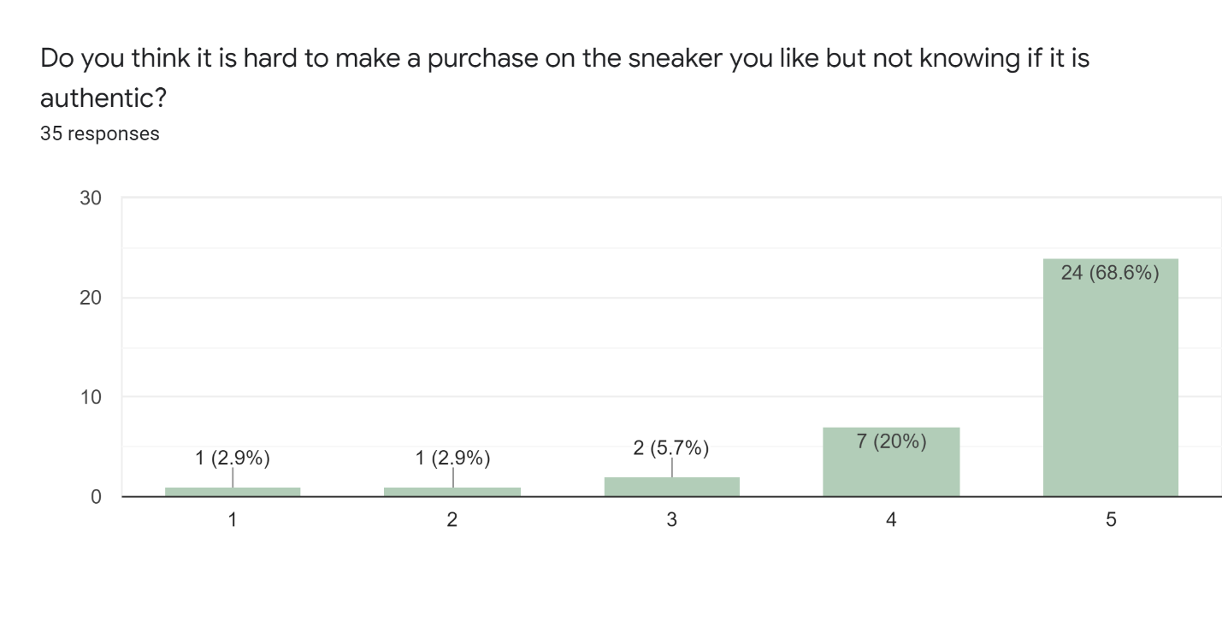

*Figure 6.1.15 Bar Chart Question 11*

Based on question 11 on figure 6.1.15, 68.6% of the respondents finds it very difficult to make a purchase before confirming the authenticity of the sneaker, 20% also feel it is difficult, 5.7% does not find it difficult, nor does the respondent finds it less difficult. 2.9% of the respondents are not affected on knowing the authenticity before purchasing the sneaker, and another 2.9% is totally not disturbed with it. Through this, it is determined that the proposed system is worth developing as the respondents feels it is difficult to purchase before knowing its authenticity.

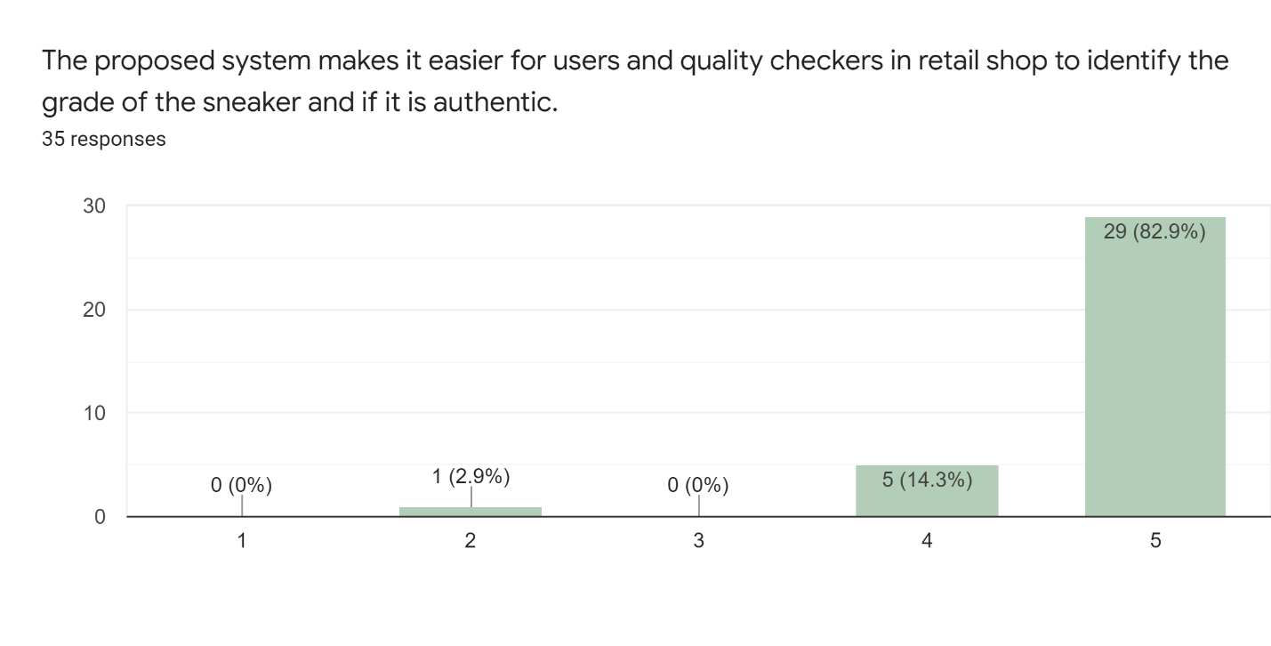

*Figure 6.1.16 Bar Chart Question 12*

Based on figure 6.1.16, 82.9% has strongly agreed, 5.14% agrees, and 2.9% disagree with the proposed system would make it easier for users to identify the grade and authenticity of the sneakers. Based on the respondents’ answer, the proposed project will be made with its function to determine and identify the grade and authenticity of sneakers.

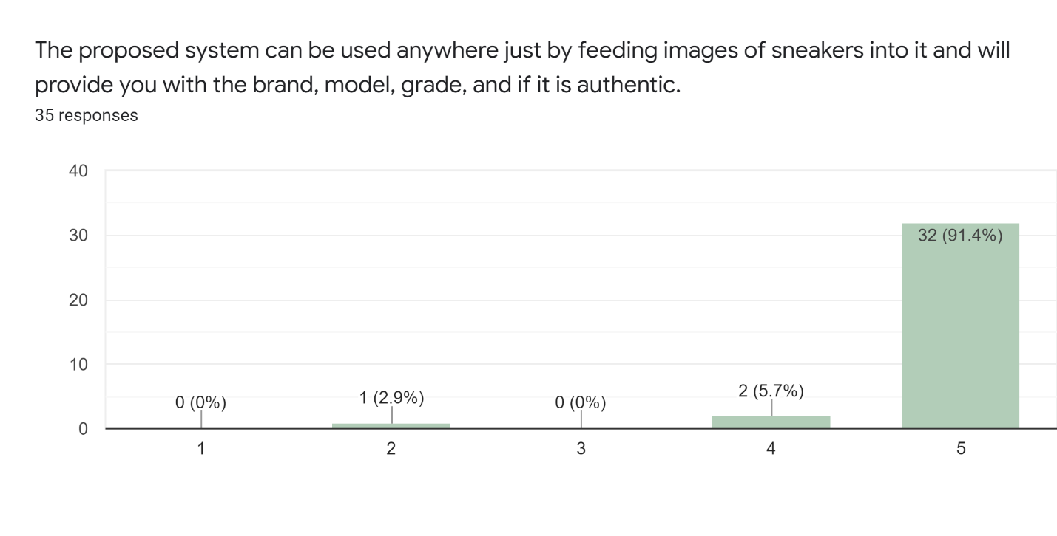

*Figure 6.1.17 Bar Chart Question 13*

The result from respondents shown in figure 6.1.17 shows that 91.4% strongly agrees, 5.7% agrees, and 2.9% disagrees with the proposed system function. The function is to feed images to the system and will provide the output of the brand, model, grade, and authenticity of the sneaker. Based on the respondents’ answer given, most of the respondents have approved the function of the proposed system.

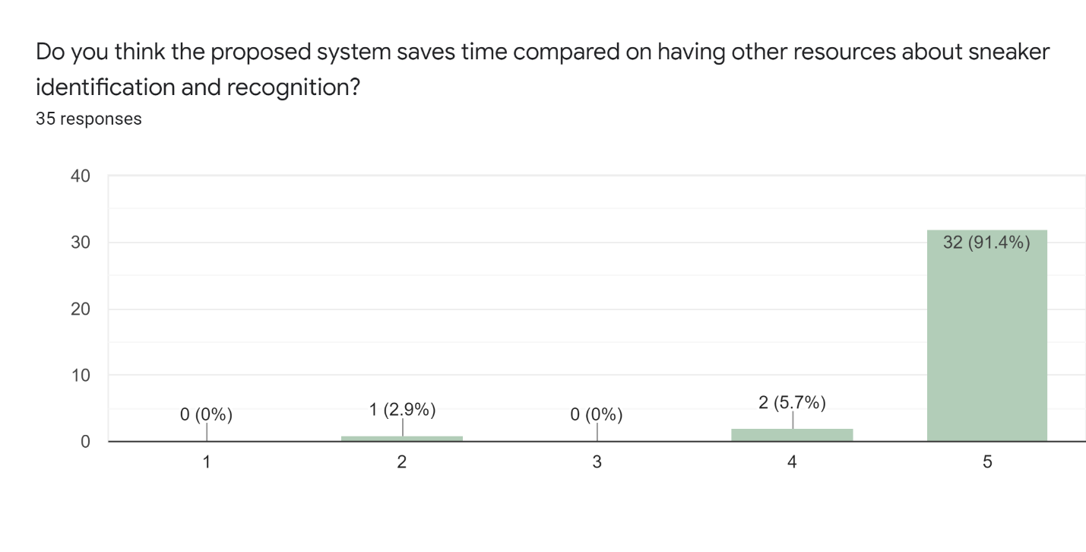

*Figure 6.1.18 Bar Chart Question 14*

Based on the question 14 on figure 6.1.18, 91.4% respondents strongly agree, 5.7% agrees, and 2.9% disagrees with the proposed system efficiency. Based on the majority of the respondent answer, the proposed system have been accepted and approved as a system that saves time instead of using other methods to search on the authenticity of a sneaker.

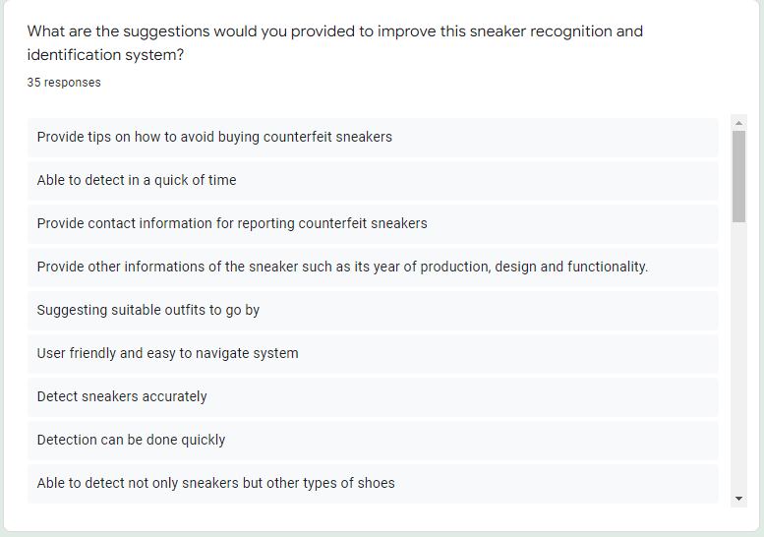

*Figure 6.1.19 Suggestions Question 15*

Figure 6.1.19 shows a list of interesting suggestions from the respondents. Based on the answer given in the list by the respondents, it may used as an enhancement for the system in the future.

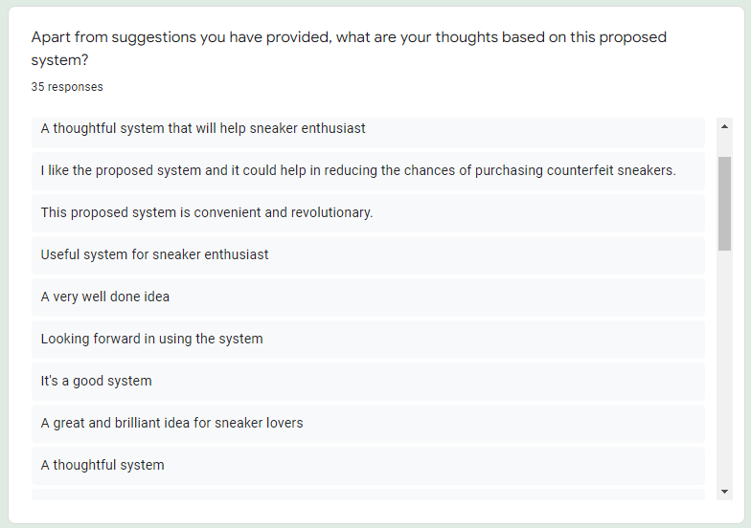

*Figure 6.1.20 Thoughts on System Question 16*

Based on 6.1.20, these are the list thoughts on the system given by respondents. With more positive thoughts given by respondents, researcher may feel motivated to develop the system.

## 6.2 Summary

Based on the data collected through questionnaire shown above respondents have effectively provided honest answer. Many respondents are supportive towards the features and have approved of the system being developed. Many opinions and positive thoughts were given by the respondents. Many of the respondents result shows in favor of the proposed system, it is believed that the proposed system will be proved to be useful, and researcher has decided to proceed with the project in developing a fully functional sneaker identification and recognition system.

# **Chapter 7: System Architecture**

This chapter of the paper will include the detail of the core features and elements, and the abstract architecture of the system.

## 7.1 Introduction

The sneaker classification web application is a system designed only to predict sneaker from the given image uploaded by users. Based on an article written by Ismael, A (2021). There are over 23 billion pairs of sneakers produced each year. From the 23 billion pairs of sneakers, there are more than 266 brands, and huge number of different models as well. This system was designed to satisfy users needs of knowing what the pair of sneakers is. The goal of this system is to provide users with accurate answer based on the prediction by using machine learning. The primary feature of this system is such as below:

1. Brand and Model prediction

This feature in the system requires multi-class prediction and it is done through machine learning. Many datasets are required to train the machine learning model for high accuracy. This component is the most important one because without knowing the brand and model of the sneaker, users have difficulties figuring out what sneaker they are searching for. The trained model is applied in the web application for predictions of the uploaded images.

1. Sneaker color variant prediction

This feature in the system also requires multi-class prediction with large number of datasets for machine learning to train. The datasets required are different color variant if each brand and model of the sneakers for high accuracy. This feature allows users to identify whether the sneaker is brand new, defect, or a used sneaker through the web application system.

1. Integration of training model to web application

This feature allows users to identify counterfeit sneakers by using the web application system by converting the trained model into a suitable file for the web application integration.

## 7.2 Abstract Architecture

This section will be on the discussion and illustration of the system design and interface design for the proposed web application system to provide more insight on the design planning process.

### 7.2.1 System Design – Sneaker Classifier Use Case Diagram

The shown below is the use case diagram and context diagram for the sneaker classifier web application. There will only be one type of actor for the use case diagram.

*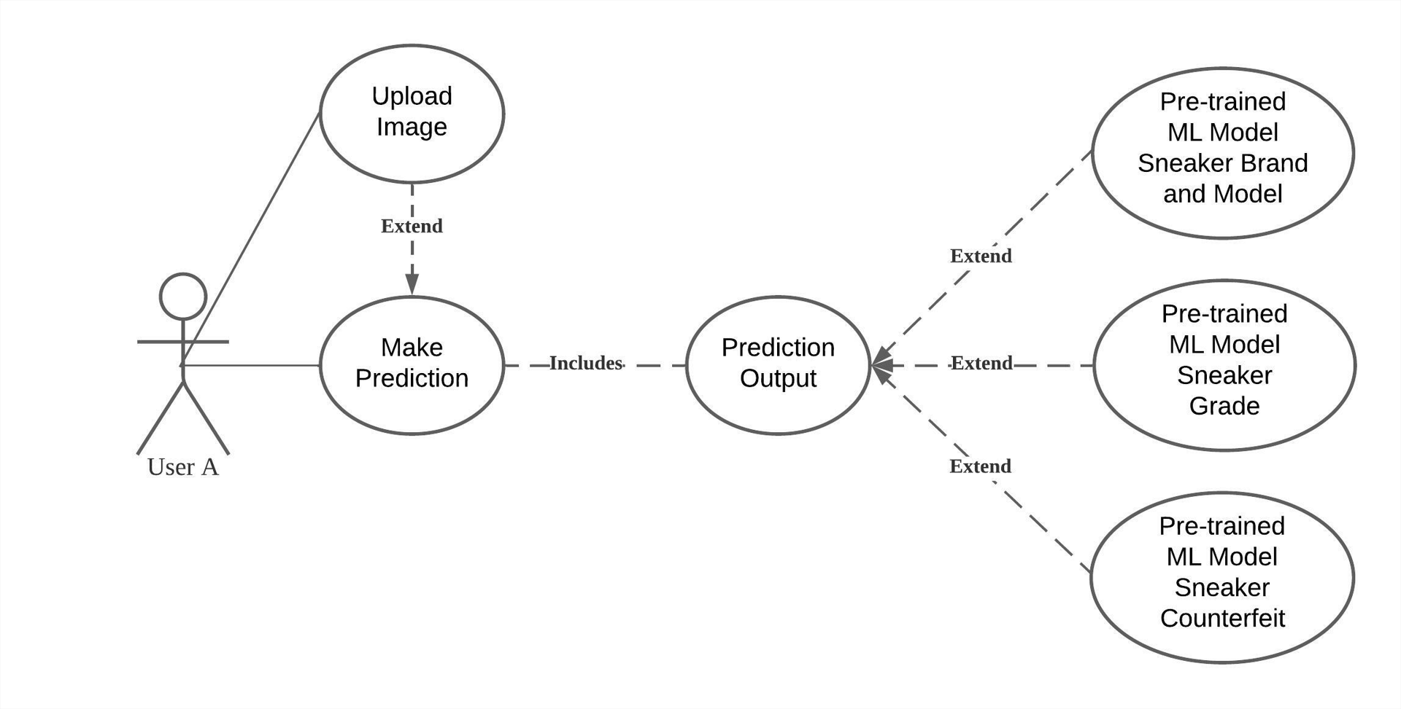 Figure 7.2.1.1 Use-Case Diagram for Sneaker Classifier Web Application (Self-captured, 2022)*

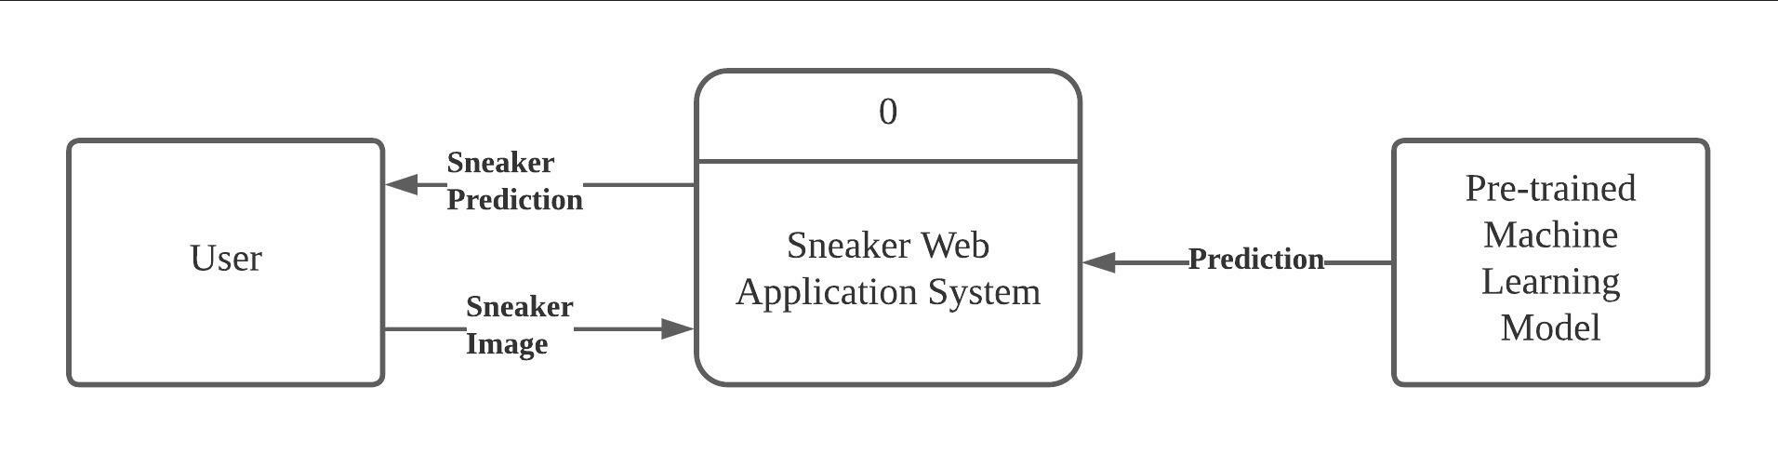 *Figure 7.2.1.2 Context Diagram for Sneaker Classifier Web Application (Self-captured, 2022)*

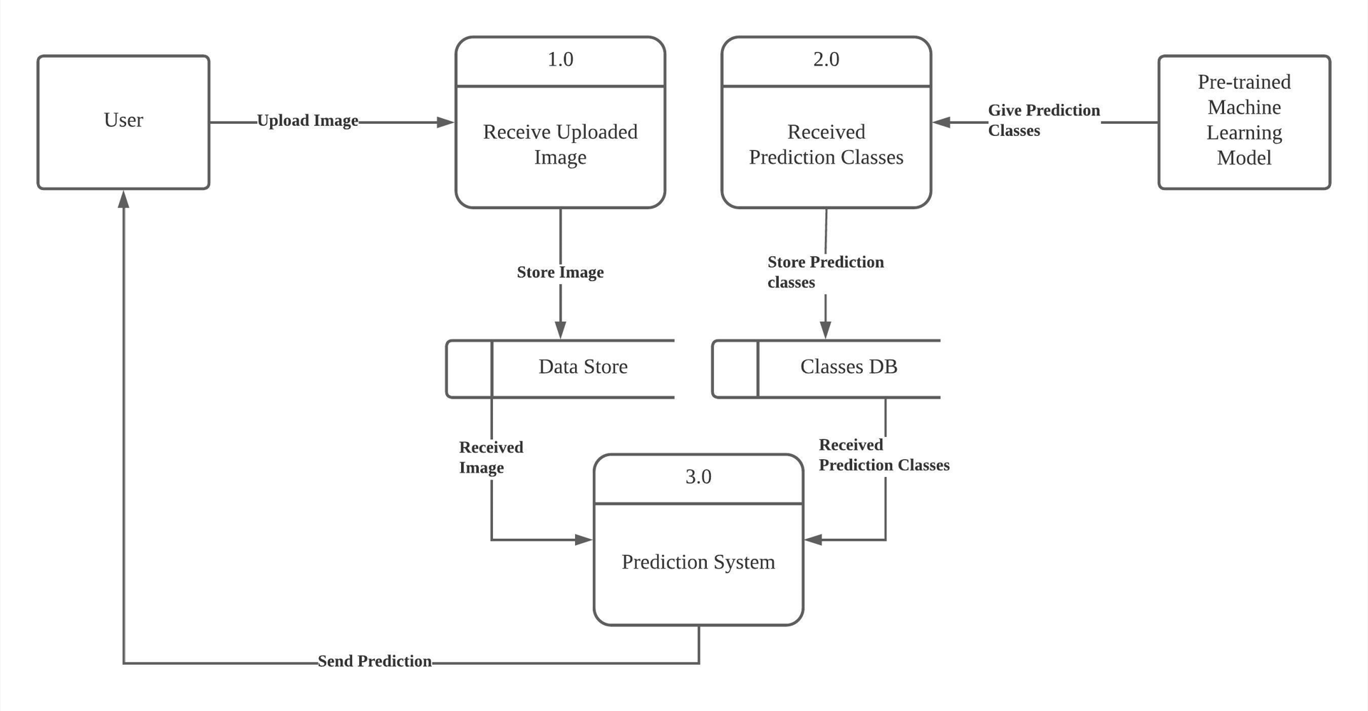

*Figure 7.2.1.3 DFD-Level 0 for Sneaker Classifier Web Application (Self-captured, 2022)*

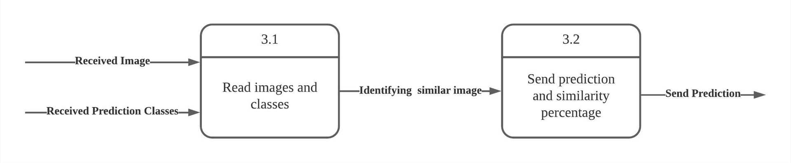

*Figure 7.2.1.3 DFD-Level 1 for Sneaker Classifier Web Application (Self-captured, 2022)*

The table below provides the overview of each function for the use-case diagram from figure 7.2.1.1.

|  |  |
| --- | --- |
| **Function Name** | Upload Images |
| **Description** | User is required to upload desired sneaker image |
| **Assumptions** | The user will only upload an image of a sneaker that they want to identify |
| **Default Workflow** | Actor uploads the image to the web application from the selected file |

|  |  |
| --- | --- |
| **Function Name** | Make Prediction |
| **Description** | User will use predict after uploading an image |
| **Assumptions** | User will view the details of predicted image |
| **Default Workflow** | Actor will view the outcome of the predicted image |

## 7.2.2 System Design

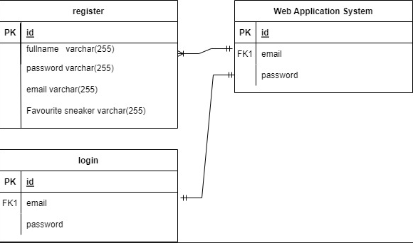

*Figure 7.2.2.1 ERD for Sneaker Classifier Web Application (Self-captured, 2022)*

The ERD shown above is simple because this system only uses the database to store and retrieve user detail for the login system in the web application.

## 7.2.3 Data Table Structure

This section will provide details on the table structure of the sneaker application web system.

|  |  |  |
| --- | --- | --- |
| Column Name | Description | Data Type |
| id | Unique id for user from registration | Auto |
| fullname | To register user detail | VARCHAR(255) |
| password | for users to key in password during login. System will validate with database | VARCHAR(255) |
| email | For users to key in email during login. System will validate with database | VARCHAR(255) |
| favourite_sneaker | To store user detail | VARCHAR(255) |

### 7.2.3 Interface Design

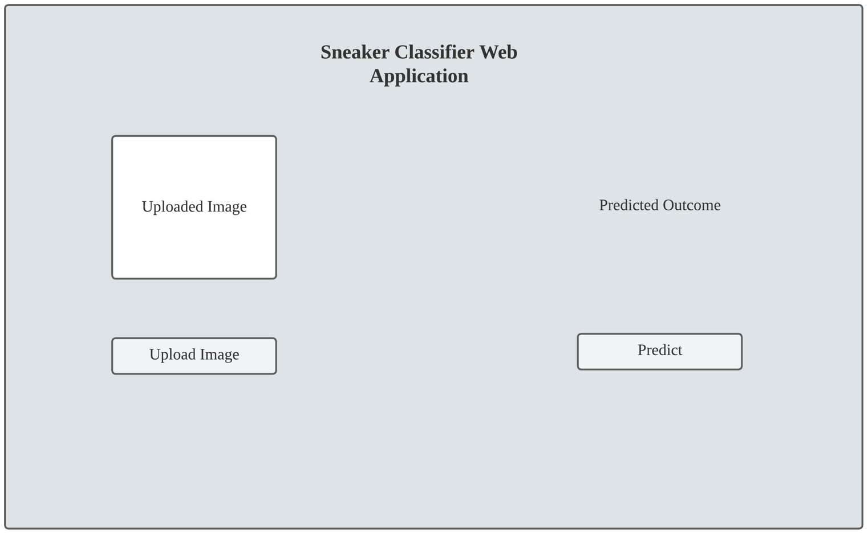

*Figure 7.2.2.1 Interface Design for Sneaker Classifier Web Application (Self-captured, 2022)*

# **Chapter 8: Project Plan**

In this section, detailed release plan on the proposed system is discussed. In this project, it is divided into two components which are data science and machine learning, and web application. A project timeline on this project in a form of Gantt chart in the Appendix section. The project is released in different milestones and will be discussed in the section below.

## 8.1 Release Plan

This section explains on the different versions release plans for Sneaker Classifier web application.

### 8.1.1 Sneaker Classifier Version 1.1

Firstly, different libraries and packages were identified to be utilized in the proposed system. The first version of the system was subjected to be released in the first week of July 2022. Since this project consist of data science and machine learning components, all matter regarding development, training and testing were conducted on Jupyter Notebook. In this first release version, it consists of the completion of the first training model. In this first training model, only 2 classifications were able to be classified. More classifications were conducted in the next few versions.

### 8.1.2 Sneaker Classifier Version 1.2

In the second release version, multiclass classification was conducted and 4 classes from the dataset were trained. Based on the result obtained from the training model, higher accuracy was achieved compared to the training conducted in the previous version.

### 8.1.3 Sneaker Classifier Version 13

In the third release, multiclass classification was successfully conducted with the full dataset that comprises of 898 different classes. Although lower accuracy was obtained, multiclass classification was fully conducted. The resulting low accuracy is due to inequal number of datasets consisting in each class.

### 8.1.4 Sneaker Classifier Version 1.4

Once training is done, a web application was built by using JavaScript and HTML in this release. Numerous errors were encountered while building the web application due to lack of knowledge in the subject field and difficulty faced in resolving the issues.

### 8.1.5 Sneaker Classifier Version 1.5

In this version, React, a JavaScript library, was used in developing the web application.

## 8.2 Project Test Plan

A test plan is crucial in conducting projects as we will be able to discover what is and is not working when tested. It is necessary in conducting a test plan to ensure the developed application or website functions properly without any errors. Explanation on the test plan for Sneaker Classifier are as discussed below:

* To ensure every function are properly functioned without any errors
* To certify every function work as expected without complication
* Once unit testing plan is completed, and system is ready to be deployed, user acceptance testing plan is conducted.
* Based on remarks from user acceptance testing plan, errors occurred will be resolved and any necessary improvement will be made.
* User acceptance testing plan sent are sent to a minimum of 3 users for the system to be tested.

### 8.2.1 Unit Testing Plan

The table below is the unit testing plan written in detailed by cases for the system.

|  |  |  |  |  |
| --- | --- | --- | --- | --- |
| **Case ID** | **Test Case** | **Test Function** | **Sample Data** | **Expected Result** |
| 1. | Testing prediction result before implementing to web application | Accuracy | Training sample | Shows 100% accuracy |
| 2. | Testing prediction result before implementing to web application | Accuracy | Validation Sample  &  Random sneaker image | Shows more than 80% accuracy |
| 3. | Implementing training model to web application | Functionality | Training model | No errors |
| 4. | Testing prediction result after implementing to web application | Accuracy | Training sample,  Validation sample,  Random sneaker image | Accuracy more than 80% |
| 5. | Click on upload button to upload image | Upload | Random sneaker image | Image uploaded into web application |
| 6. | Click on predict button to predict uploaded image | Predict | Random sneaker image | Image predicted with class name / sneaker name |
| 7. | Database connection | Database | System Application | Successfully connected |
| 8. | Real-time database steaming | Database | System Application | Data written correctly and matches the time. |
| 9. | Firebase Database queries | Data pipeline | Database | SQL queries executes correctly |
| 10. | Registering users by keying in details | Register | Users | Successfully registered user to the database |
| 11. | Loging in the system upon registration | Login | Users | Successfully retrieve user log in from database |
| 12. | Page navigation from dashboard to prediction page | Navigation | Buttons | Successfully navigate from one page to another |

### 8.2.2 User Acceptance Plan

This section will be the discussion on the user acceptance plan to be executed before deployment of this system. The system will be given to several users, targeted users are mainly sneakerheads. Upon completion of the test by the users, they will be provided with a user feedback form. This form will be recorded and kept for future improvements that can be made based on the feedback provided by the test users. Below are the images of the user acceptance feedback form.

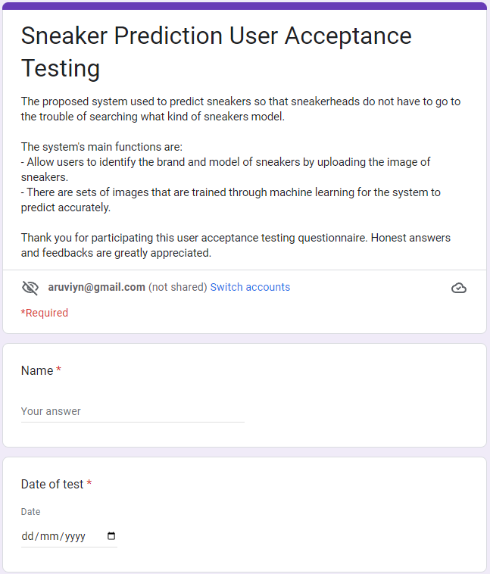

*Figure 8.2.2.1 User Acceptance Testing Form 1 (Self-captured, 2022)*

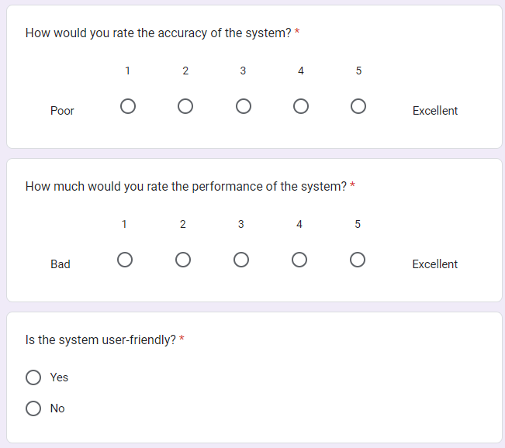

*Figure 8.2.2.2 User Acceptance Testing Form 2 (Self-captured, 2022)*

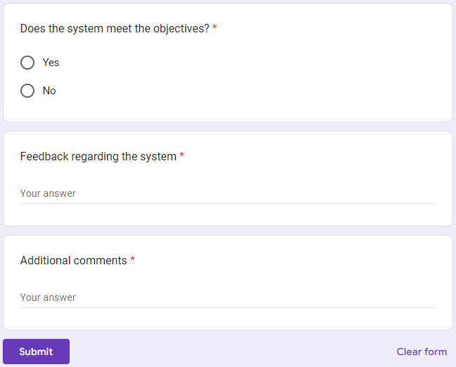

*Figure 8.2.2.3 User Acceptance Testing Form 3 (Self-captured, 2022)*

# **Chapter 9: Implementation**

In this chapter, the developer will walk through the functionalities of the system application in detailed manner through screenshots of the codes that are used for the development of this system. The screenshots of the codes are then discussed.

## 9.1 Screenshots

### 9.1.1 Login Page User Interface (UI)

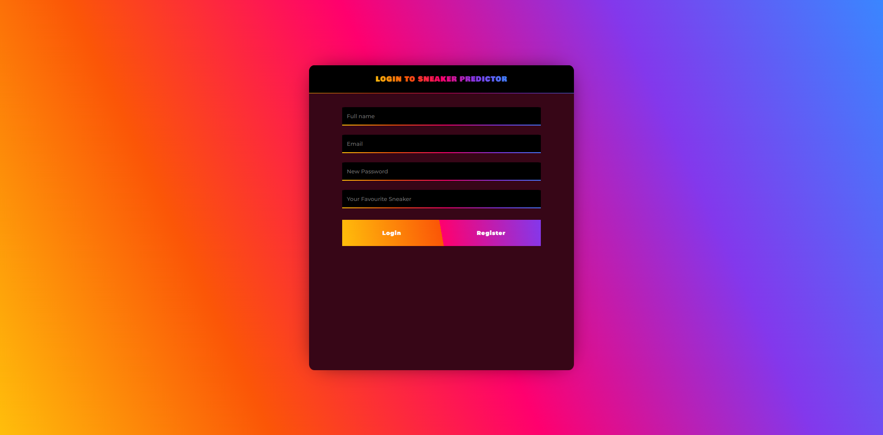

*Figure 9.1.1.1 Login Page User Interface (Self-captured, 2022)*

This login user interface requires users to register an account and login before navigating to the next user interface. To register, users are required to fill in their name, email, password, and favourite shoes. Upon registering, the system will save it in the database. Users must key in their email and password to login.

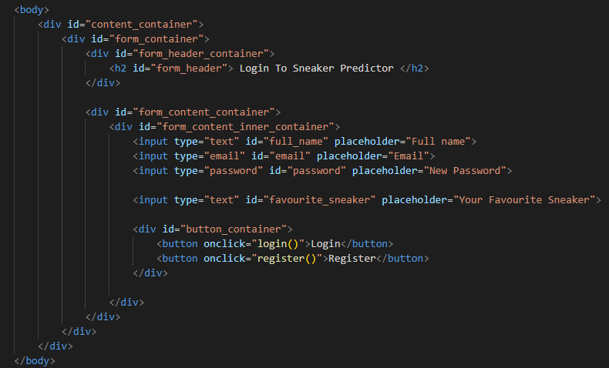

*Figure 9.1.1.2 Login Page HTML file (Self-captured, 2022)*

The screenshot above is the code for the login page done in HTML file. The login user interface was customized using the codes that are written in CSS. The login and register button each has its own function that will store and retrieve information from the database. The functions are written in JavaScript. Due to long line of codes, these functions and database implementation will not be shown in screenshots.

### 9.1.2 Dashboard UI

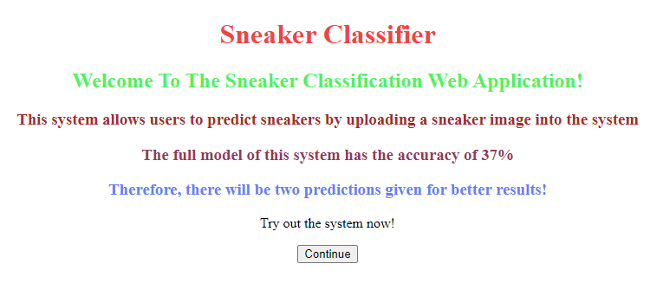

*Figure 9.1.2.1 Dashboard UI (Self-captured, 2022)*

The screenshot shown above is the dashboard UI. After successfully logging in, the system will navigate users to this page where users can read about the main function of this system. Upon clicking continue, the system will navigate users to the page where users can upload images and allow system to make predictions.

### 9.1.3 Prediction UI

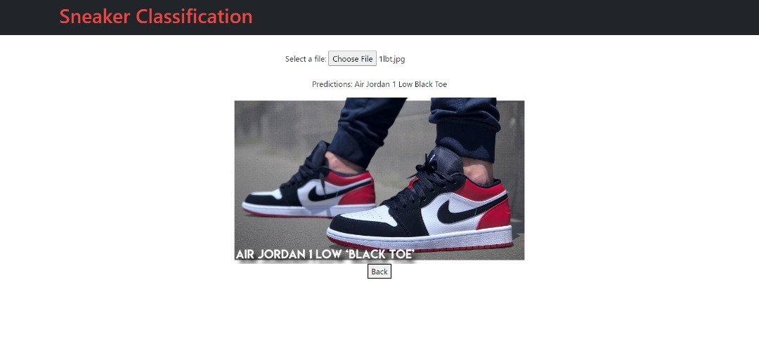

*Figure 9.1.3.1 Prediction UI (Self-captured, 2022)*

The screenshot shown above is the user interface of the prediction page. This page is where users can upload sneaker images and allow the system to predict the name of the sneaker based on the image uploaded. Users can go back to the dashboard by clicking the back button. Below will be the discussion of the HTML file that is done to create this user interface.

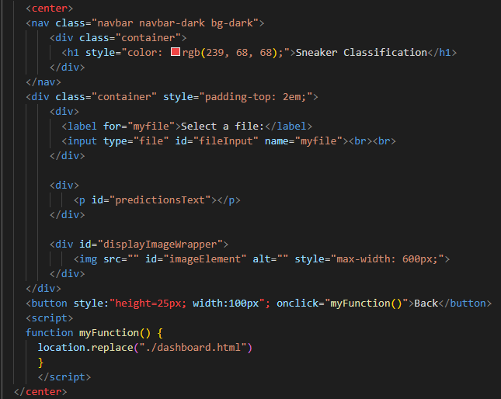

*Figure 9.1.3.2 Prediction HTML File (Self-captured, 2022)*

The HTML screenshot above is used to create the prediction UI shown in figure 9.1.3.1. The color done for sneaker heading 1 is customized by using the color property. The functions of uploading file and predictions will be discussed further in the below section.

## 9.2 Sample Codes

### 9.2.1 TensorFlow Libraries

To predict a sneaker, the system must first be trained. The dataset will be trained using TensorFlow model. There are several libraries used for this training model. But the most important library is the TensorFlow library. The screenshot below shows the libraries used for the model.

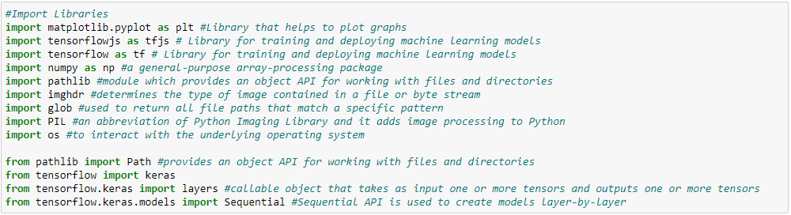

*Figure 9.2.1.1 Jupyter Notebook import libraries (Self-captured, 2022)*

The code screenshot shown above is the library used in Jupyter Notebook to create the machine learning model. Sequential is used to call the API to create layers for the training model. Layers is used as a callable object that takes an input of one or more tensors and outputs of one or more tensors. These are necessary libraries to be used to train a model using TensorFlow.

### 9.2.2 TensorFlow Model

The code screenshot shown below is the model creation and model summary.

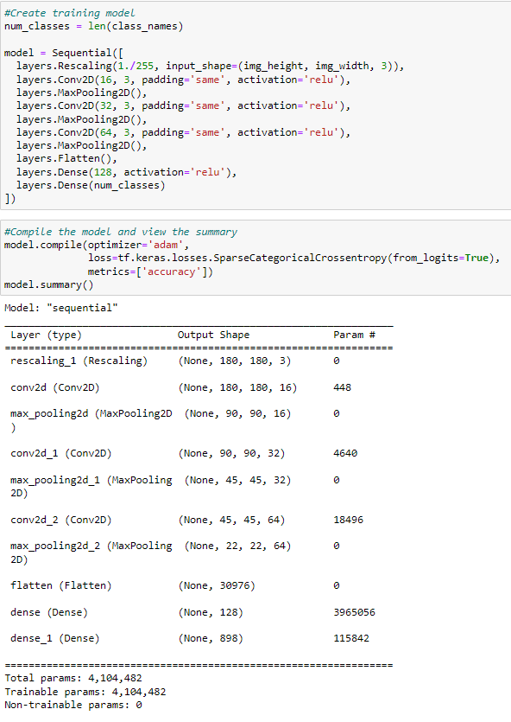

*Figure 9.2.2.1 Jupyter Notebook creating training model (Self-captured, 2022)*

The model created above is done through sequential layering which adds layer by layer. The layers that are included are as written in the code, and layers can be either edited or removed. ReLu is a linear function that output the input immediately if it is positive, if not it will output zero. It is easy, fast and analytically works well. Now that the model has been created by the developer, the next is to continue with the training which will be done with 15 epochs. After training the model will be saved and the saved model can be loaded for prediction later.

### 9.2.3 Testing the Model

The code of the screenshot shown below is used to test the model that has been trained and saved. The screenshot also provides the accuracy of the test done.

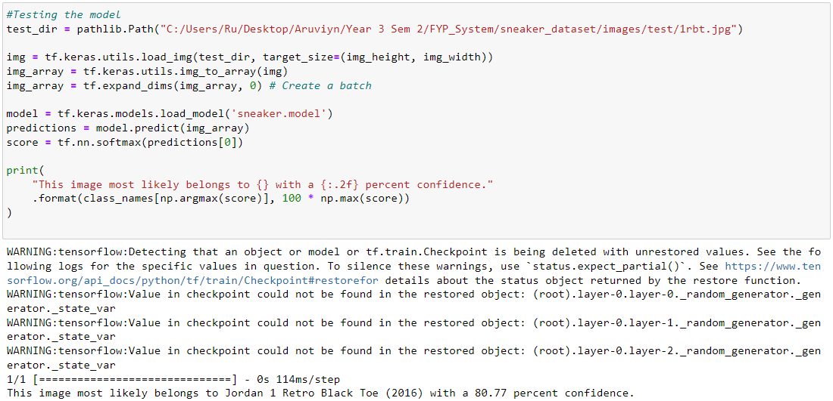

*Figure 9.2.3.1 Jupyter Notebook creating training model (Self-captured, 2022)*

To test the model, a path to the image is set to a variable. The model must first be loaded to predict the image that at the variable, in this case the variable will be test_dir. The model has identified the sneaker image with 80.77 percent confidence which is highly accurate.

### 

### 9.2.4 Converting the Model.

After completing the model with satisfied accuracy, the screenshot below shows the code of converting the model from TensorFlow to TensorFlowJS.

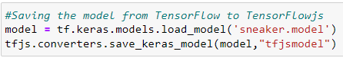

*Figure 9.2.4.1 Jupyter Notebook creating training model (Self-captured, 2022)*

Converting the model from TensorFlow to TensorFlowJS allows the model to be used in JavaScript, where the system is built on. The model is loaded to a variable and the TensorFlowJS converts the model which was saved in the variable to a new folder named tfjsmodel.

## 9.2 System Implementation.

In this section the developer uses the converted model to implement in the system. This section also provides an overview of the user interface and the main functionalities.

### 9.2.5 Naming the classes for prediction

To predict the sneakers in the web browser, the name of the classes must be defined. The screenshot code below is how the developer defined a variable to the classes for prediction.

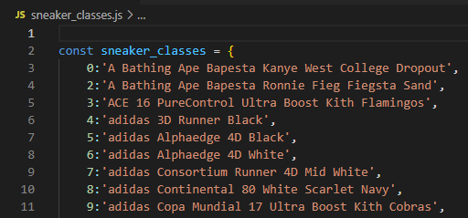

*Figure 9.2.5.1 Visual Studio Code Defining All classes (Self-captured, 2022)*

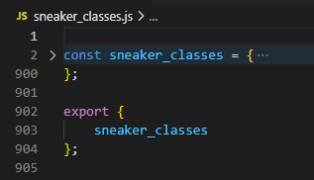

*Figure 9.2.5.2 Visual Studio Code Exporting Class (Self-captured, 2022)*

After defining a variable to the classes, the classes must be exported to where the prediction code file is.

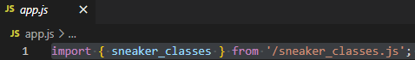

*Figure 9.2.5.3 Visual Studio Code Importing Class (Self-captured, 2022)*

The developer then imports the file to the code where the prediction function takes place. Without these classes defined and imported, the prediction will have no class to provide.

### 9.2.6 Uploading image function

The code screenshot below shows how user can upload image into a web browser.

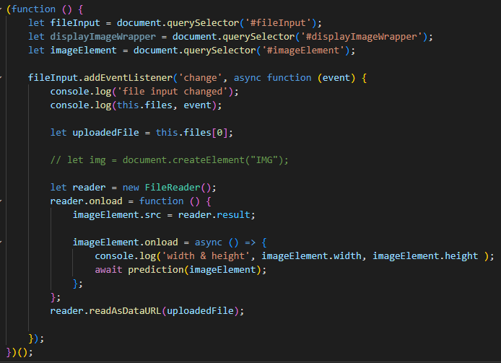

*Figure 9.2.6.1 Visual Studio Code Upload Image Function (Self-captured, 2022)*

The code function above allows image upload into the web system. The image size is set to the original size of the image width and height. The code “let” detects changes, logs the event, and read in the uploaded file as data. In this case, it is listening for changes on an input called the #fileInput. It uses event listener to detect when this happens, which triggers the callback function with two parameters. At the end of the code, it reads any image uploaded by users as data URL using FileReader’s readAsDataURL method and assigns it to imageElement’s source attribute. By calling this function, users can upload images at the web application.

### 9.2.7 Prediction function

The code screenshot below shows the function for prediction.

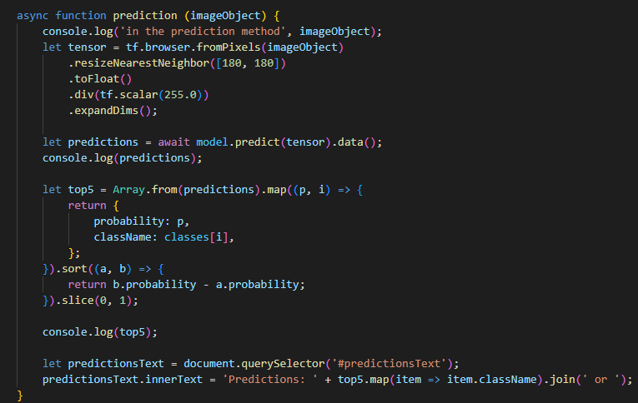

*Figure 9.2.7.1 Visual Studio Code Prediction Function (Self-captured, 2022)*

The async and await keyword enables asynchronous, promised-based behavior to be written. This is where the code will be executed and used to display information about what is happening in the system, which is the predictions. In the function, the image uploaded by users will be pre-processed before prediction happens. This allows the system to predict more accurately.

### 9.2.8 Importing TensorFlowJS model

The screenshot below is where the previously converted model folder should be placed. The path of the folder and the contents of the folder is important for the system to do predictions.

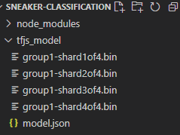

*Figure 9.2.8.1 Visual Studio Code TFJS Model Path (Self-captured, 2022)*

It is important for the developer to have the saved model into the path of the system. This is because the model.json is required to be implemented in the system for predictions to happen. Without the model.json, the prediction will not happen.



*Figure 9.2.8.2 Visual Studio Code Calling model.json (Self-captured, 2022)*

By having this line of code, the model.json will be defined as model. The model is then called back in the figure 9.2.7.1 where it is used in the prediction function.

### 9.2.9 Button and id

In the screenshot code below shows the button in the html file for the user interface of the web system.

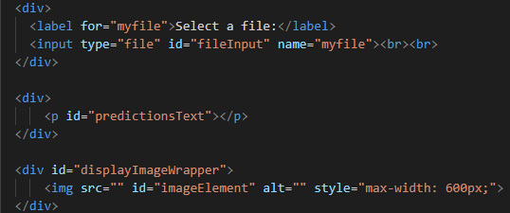

*Figure 9.2.9.1 Visual Studio Code Buttons in HTML File (Self-captured, 2022)*

The two buttons in this html file each has its own unique id which are fileInput and predictionText. The fileInput calls the function back from figure 9.2.6.1 where the upload image function is done, and the predictionText calls the function back from figure 9.2.7.1. Once user has uploaded the image into the web system, the prediction will automatically happen and provide the predicted output.

# **Chapter 10: System Validation**

## 10.1 Unit Testing Results – Sneaker Classification System

This section will be the discussion on the unit testing that was done for this system before moving on to the user acceptance test. This test is done to confirm that all functionalities are working without any error so that other users will not encounter any error during the user acceptance test.

|  |  |  |  |  |  |  |
| --- | --- | --- | --- | --- | --- | --- |
| **Case ID** | **Test Case** | **Test Function** | **Sample Data** | **Expected Result** | **Actual Result** | **Remarks** |
| 1. | Testing prediction result before implementing to web application | Accuracy | Training sample | Shows 100% accuracy | Result shown 96% | Testing passed |
| 2. | Testing prediction result before implementing to web application | Accuracy | Validation Sample  &  Random sneaker image | Shows more than 80% accuracy | Result shown above 80% for validation sample and above 60% for random sneaker image sample | Testing passed with low accuracy |
| 3. | Implementing training model to web application | Functionality | Training model | No errors | Result as expected | Testing passed |
| 4. | Testing prediction result after implementing to web application | Accuracy | Training sample,  Validation sample,  Random sneaker image | Accuracy more than 80% | Result shown above 70% for validation sample and above 30% for random sneaker image sample | Testing passed with low accuracy |
| 5. | Click on upload button to upload image | Upload | Random sneaker image | Image uploaded into web application | Result as expected | Testing passed |
| 6. | Image prediction once image is uploaded | Predict | Random sneaker image | Image predicted with class name / sneaker name | Result as expected | Testing passed |
| 7. | Database connection | Database | System Application | Successfully connected | Result as expected | Testing passed |
| 8. | Real-time database steaming | Database | System Application | Data written correctly and matches the time. | Result as expected | Testing passed |
| 9. | Firebase Database queries | Data pipeline | Database | SQL queries executes correctly | Result as expected | Testing passed |
| 10. | Registering users by keying in details | Register | Users | Successfully registered user to the database | Result as expected | Testing passed |
| 11. | Loging in the system upon registration | Login | Users | Successfully retrieve user log in from database | Result as expected | Testing passed |
| 12. | Page navigation from dashboard to prediction page | Navigation | Buttons | Successfully navigate from one page to another | Result as expected | Testing passed |

## 10.2 User Acceptance Testing Result – Sneaker Classification System

This section will be the discussion on the results obtained from user acceptance testing. The user acceptance testing is done by having other users to test the system and provide feedback. The feedback form was handed to user upon completion of the system testing. The results are as shown below:

Name:

These are the names of the users who participated the user acceptance testing for this system and have completed the feedback form.

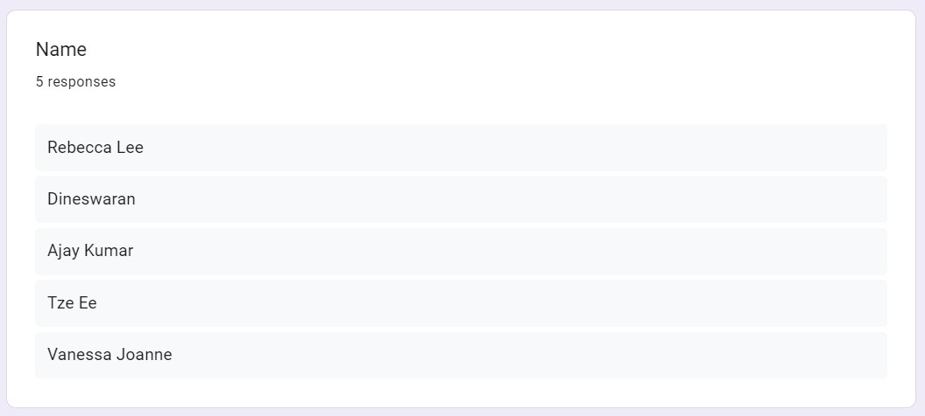

*Figure 10.2.1 UAT question 1 (Self-captured, 2022)*

Date of Test:

The image below shows the date of test done by the users.

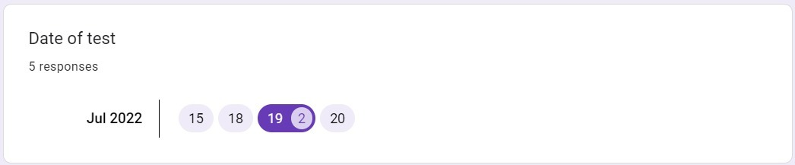

*Figure 10.2.2 UAT question 2 (Self-captured, 2022)*

Rate of system accuracy

The image shown below is the rating of accuracy done by the participating users. Based on the rating provided, future work will be done by increasing the accuracy of the prediction system.

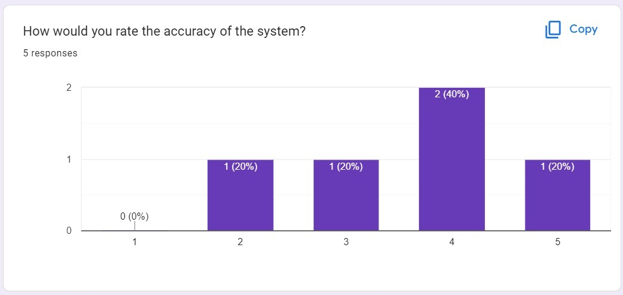

*Figure 10.2.3 UAT question 3 (Self-captured, 2022)*

Rate of system performance

The image shown below is the rating of system performance done by the participating users. Majority of the user who tested this system are satisfied with the system performance. Since there is one user that is unsatisfied, improvements can be made.

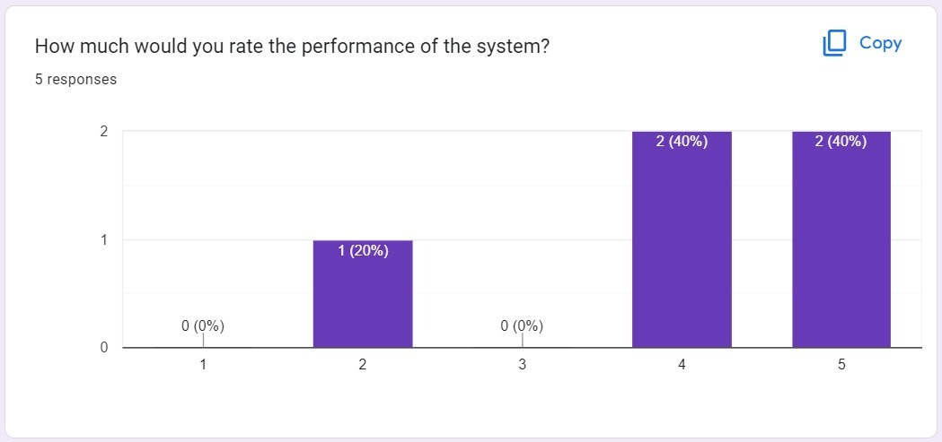

*Figure 10.2.4 UAT question 4 (Self-captured, 2022)*

Is the system user friendly?

Based on the results shown below, all the participants agrees that the system is user friendly.

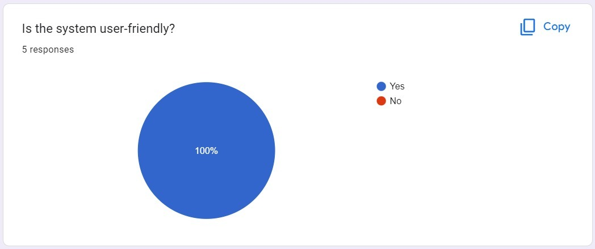

*Figure 10.2.5 UAT question 5 (Self-captured, 2022)*

System objectives

Based on the results shown below, all the participants agrees that the system has met the objectives.

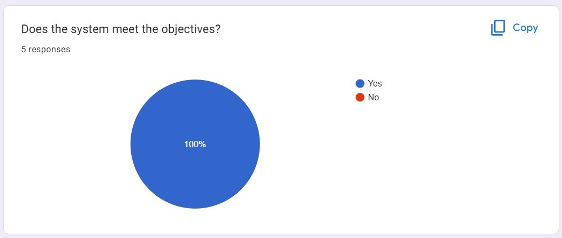

*Figure 10.2.6 UAT question 6 (Self-captured, 2022)*

Feedback regarding system

Based on the results obtained from the participants, there are positive and negative feedbacks obtained. The negative feedback can be kept in mind for future enhancement of the system.

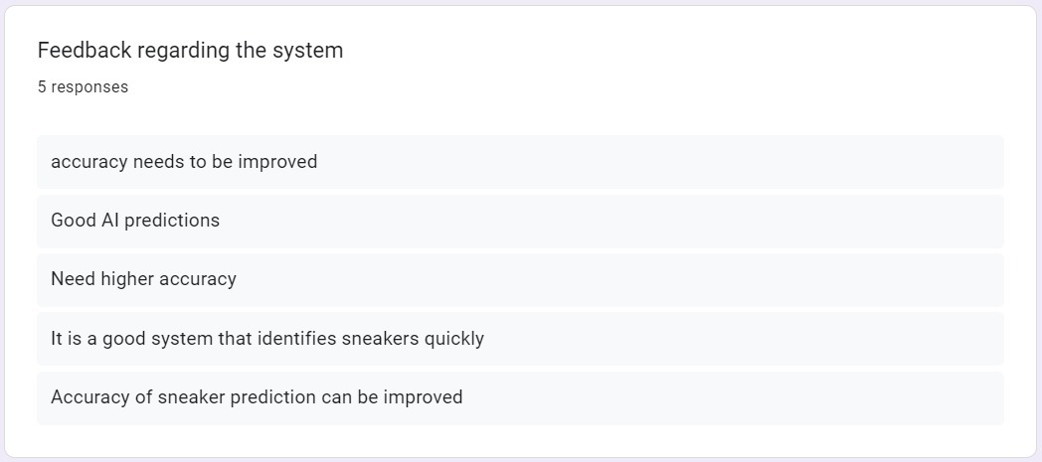

*Figure 10.2.7 UAT question 7 (Self-captured, 2022)*

Additional comments

Based on the comments shown below by the participants, there are improvements and enhancements that can be done for the system. These improvements and enhancements will be done for the future work.

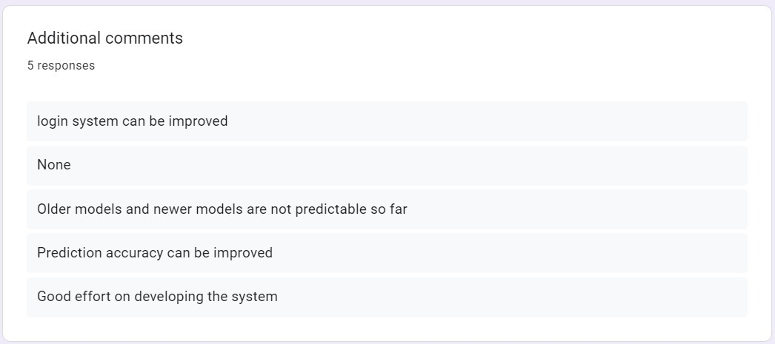

*Figure 10.2.8 UAT question 8 (Self-captured, 2022)*

## 10.3 Summary

The developer has conducted unit testing and user acceptance testing for the sneaker classification system and has met all the requirements with not functionality errors, and it is fully functional. The unit testing has been done and recorded based on the table above. The user acceptance testing conducted (UAT) with the sneakerheads was done appropriately and obtained feedbacks along with comments on the system expectations. Looking through the data gathered from the UAT, most of the feedbacks and comments was on the positive side, whereas the negative side is where the developer can work on for improvements in the future. All in all, the sneaker classification web application system is has thrived in the tests done.

# **Chapter 11: Conclusion and Reflections**

This chapter will be the summary of this documentation with critical evaluation for this project in detailed manner. This chapter will also include the reflections to be done by the researcher along with the future works for this project and conclude the documentation.

## 11.1 Critical Evaluation

In this section, the developer will summarize the benefits of the system, the limitation of the system, the future work to be done for the system, evaluation of the methodology implemented, and critical evaluation summary.

### 11.1.1 Aims and Objectives of the System

The aims and of this project are to integrate the system into a web application where users can utilize the system through devices with web browser. The objective of this project is to implement a proper machine learning model to train large dataset, design user-friendly graphical user interface and do test before the deployment of the system. The aims and objectives have been achieved with and the integration of artificial intelligence (AI) to classify sneakers has been done with a good amount of accuracy. The model was robust enough to predict huge datasets with the outcome of a decent accuracy. The system benefits is that the prediction can be done by just uploading image which is easy and efficient rather than manually searching for the sneaker in need.

### 11.1.2 System Limitations

The system has several limitations due to the lack of time and knowledge. The first limitation is that the machine learning model takes a very long time to train the dataset due to lack of proper resources on the device that the model is being trained at. The model took up to 6 hours of training with batch size of 32 and 15 epochs. The training was done several times to achieve a decent accuracy. The second limitation of the system is that the system only predicts the sneaker brand, model, and color variant. Due to lack of time and knowledge, the idea of implementing counterfeit sneaker prediction and grade prediction sneaker was not implemented. The second limitation can be worked in the future. The third limitation will be the database management for each account where every user has the history of which model, they have uploaded for prediction. The third limitation can also be done in the future work to further improve the system. Next, the accuracy of the model which has been implemented into the system can also be further increased. The increase of accuracy will surely help users to predict sneakers more accurately. Due to the lack of sub datasets in certain class from the main dataset, the accuracy of certain sneaker with lesser dataset could not be predicted accurately.

### 11.1.3 Future works for the system

The future works that can be done to further improve the system will firstly be the improvement of accuracy. As mentioned above in the limitations, the improvement of datasets for each class folder dataset will greatly boost the accuracy of this prediction system. Apart from that, the implementation of counterfeit as well as grade prediction will also be included from the limitation as it is an additional feature to the sneaker prediction system. Next, the database for users to have search history will also be implemented in near future as it will be convenient for users to look back on what they have searched. Lastly, an additional feature will also be worked in the future where users can be directed to where the predicted sneaker are sold, be it a physical store or e-commerce platform.

### 11.1.4 Evaluation on Methodology Used

The methodology that was chosen for waterfall. This methodology has 5 common stages which are requirements analysis, design, development, testing, and maintenance. Waterfall methodology does not start other phases until the first phase is done. By using this methodology, developer was able to follow through the phases and complete the system on time. The requirement analysis was done by obtaining the dataset, choosing proper machine learning model, programming languages to be used, choosing suitable IDE, and suitable database. The design phase is where developer design the technical solution set out by the requirements. Once the design was done, the technical implementation starts, which is the development of the system. Upon completing the system, tests are done through unit testing and UAT. Lastly, the maintenance to be done which will also be considered as a future work. All in all, the waterfall methodology has helped the developer to finish the project in a timely manner.

### 

### 11.1.5 Evaluation Summary

In the above sections, the discussion of critical evaluation has been done on aims and objective of system, system limitations, future works, and evaluation of methodology used has been done. The data gathered from the UAT form will be analyzed for further reflection and limitations of the project. These reflections and limitations will be discussed in the below section.

## 11.2 Conclusion

Towards the end of this research, there are still many to discuss. This project has been written by the researcher and developer himself with guidance of project supervisor who have been supporting since the start of this project. From the first chapter of this paper, the researcher has introduced the project background, problem statements, aims and objectives, benefits, deliverables, nature of challenges, and the project timeline of the whole project done. Next, the researcher has done literature review on similar projects that could be the solution for the proposed system. the researcher also identified similar system to the proposed system to study it for further understanding. The researcher then conducted technical research to identify the best resources to develop the proposed system. Methodologies were also compared and chosen the suitable one for this project. The researcher then conducted research methods to justify the solution proposed and analyze the research data obtained. Upon completion of the analyzing, a detailed system architecture was designed, and project plan was discussed. From there, the researcher has completed the proposed system by then and discussed the implementation of codes. Upon completion of the system, the researcher also did two tests which are unit testing and user acceptance testing. Finally, the researcher conducted a critical evaluation on the whole project done.

### 11.2.1 System Limitation

Even with the system completed, it surely has limitation. As discussed at the critical evaluation, the system has several limitations. The main limitation of the system would be the accuracy. Due to not having high enough accuracy, it disrupts the prediction when user wants to predict a sneaker. Apart from that, based on the UAT feedback and comments, it has also mentioned that accuracy is an issue. UAT feedback form also mentioned that there can be improvements done at the login page. With these limitations expressed by other users, it is clear on what needs to be worked on.

### 11.2.2 Reflection

The system which was completed was not up to the researchers satisfactory as there are many more features to be implemented. Due to the time constrain and lack of knowledge, the features are unable to be implemented. Apart from that, there is also the model training time faced by the researcher which has led to not very high accuracy of the model. with mode time given for the project, the researcher would have improved the accuracy and implement more features into the sneaker classification web application system. All in all, this project was insightful which greatly improves the researchers technical and research skills. The researcher has managed to deliver the project in time, which also helps in improving time management for the researcher. The researcher plans to further continue in the field of artificial intelligence (AI) to help solve difficult problems and make it look easy. But first, the researcher will face the limitations of this project.

# **References**

# 1.0 Bibliography

Arsenault, C. (2017, April 20). *The Pros and Cons of 8 Popular DatabasesThe Pros and Cons of 8 Popular Databases*. Retrieved from keycdn: https://www.keycdn.com/blog/popular-databases

Bhandari, P. (2020, June 12). *What Is Quantitative Research? | Definition, Uses and Methods*. Retrieved from Scribbr: https://www.scribbr.com/methodology/quantitative-research/#:~:text=Quantitative%20research%20is%20the%20process,generalize%20results%20to%20wider%20populations

Bhatt, A. (2021, January 17). *Visual Studio v/s VS code? | IDE or Editor?| Find out what you need! | Make an informed Choice*. Retrieved from Medium: https://medium.com/analytics-vidhya/visual-studio-v-s-vs-code-ide-or-editor-find-out-what-you-need-make-an-informed-choice-5bb2a4f48ec2

BoPing, Z. (2021). Analysis on the Current Situation and Future Development of Sneaker Resale Market. *Proceedings of the 6th International Conference on Financial Innovation and Economic Development (ICFIED 2021).*

BoTreeTechnologies. (2021, June 15). *Python or Node.js: Which is Best for your Web Application?* Retrieved from Medium: https://medium.com/geekculture/python-or-node-js-which-is-best-for-your-web-application-b2f001fba2e0

Braithwaite, N. (2021, May 18). *How sneakers became a $79 billion business—and an undisputed cultural symbol for our times*. Retrieved from Fast Company & Inc: https://www.fastcompany.com/90637534/how-sneakers-became-a-79-billion-business-and-an-undisputed-cultural-symbol-for-our-times#:~:text=The%20global%20sneaker%20market%20was,sneakers%20are%20considered%20big%20business

Capozzi, C. (2017, September 26). *What Is the Difference Between Tangible & Intangible Benefits?* Retrieved from Bizfluent: https://bizfluent.com/info-8094073-difference-between-tangible-intangible-benefits.html

Chien, C. (2020, February 4). *What is Rapid Application Development (RAD)?* Retrieved from CodeBots: https://codebots.com/app-development/what-is-rapid-application-development-rad

Domantas, G. (2022, April 28). *What Is NGINX? How Does It Work?* Retrieved from Hostinger: https://codebots.com/app-development/what-is-rapid-application-development-rad

*Fake Sneakers taking shoppers for a run*. (n.d.). Retrieved from RedPoints: https://www.redpoints.com/blog/fake-sneakers/

Gawron, K. (2017, October 11). *What is Node.js and Why You Should Use It For Enterprise Software?* Retrieved from Monterail: https://www.monterail.com/blog/nodejs-development-enterprises

Gray, S. (2022). *Software Development: 7 Phases of Design & Development Process*. Retrieved from Custom Software Lab: https://www.customsoftwarelab.com/software-development-7-phases-of-design-development-process/

Gubler, B. (2019, April 24). *TensorFlow.js: An intro and analysis with use cases*. Retrieved from LogRocket: https://blog.logrocket.com/tensorflow-js-an-intro-and-analysis-with-use-cases-8e1f9a973183/

Huthaifa Almogdady, D. S. (2018). A Flower Recognition System Based On Image Processing And Neural Networks. *International Journal of Scientific & Technology Research*.

Ismael, A. (2021, April 21). *One sneaker takes up to 40 years to decompose in a landfill. These 10 brands are changing that by making shoes from recycled and renewable materials.* Retrieved from Review: https://www.insider.com/guides/style/sustainable-sneaker-brands

Khalifa, O. &. (2007). *Malaysian Vehicle License Plate Recognition*. Retrieved from ResearchGate: https://www.researchgate.net/publication/220413760_Malaysian_Vehicle_License_Plate_Recognition

Korsun, J. (2019, September 17). *The 16 Most Important Pros and Cons of using Python for Web Development*. Retrieved from Django Stars: https://djangostars.com/blog/python-web-development/

Lab, B. (2022). *How AI Can Protect Retailers and Consumers From Counterfeits*. Retrieved from Brouton Lab: https://broutonlab.com/blog/ai-to-recognize-counterfeits#:~:text=Artificial%20intelligence%20companies%20use%20computer,legit%20and%20the%20other%20fake

Liu, L. &. (2020). *Image Recognition Technology Based on Machine Learning*. Retrieved from ResearchGate: https://www.researchgate.net/publication/344562543_Image_Recognition_Technology_Based_on_Machine_Learning

Lux, M. &. (2018, January). *Sole value – the sneaker resale market : an explorative analysis of the sneaker resale market*. Retrieved from ResearchGate: https://www.researchgate.net/publication/332330011_Sole_value_-_the_sneaker_resale_market_an_explorative_analysis_of_the_sneaker_resale_market

Mangundap1, B. C. (2018). COMPARATIVE RESEARCH OF CONSUMER PURCHASE INTENTION TOWARDS.

Matthews, D. &.-C. (2021). *I wear, therefore I am: investigating sneakerhead culture, social identity, and brand preference among men*. Retrieved from ResearchGate: https://www.researchgate.net/publication/348237808_I_wear_therefore_I_am_investigating_sneakerhead_culture_social_identity_and_brand_preference_among_men

Maynard-Reid, M. (2018, April 21). *Anaconda, Jupyter Notebook, TensorFlow and Keras for Deep Learning*. Retrieved from Medium: https://margaretmz.medium.com/anaconda-jupyter-notebook-tensorflow-and-keras-b91f381405f8

Nguyen, N. &. (2016). Flower species identification using deep convolutional neural networks. *Regional Conference on Computer and Information Engineering (RCCIE 2016).* Retrieved from https://www.researchgate.net/publication/308322586_Flower_species_identification_using_deep_convolutional_neural_networks

Nyakundi, H. (n.d.). *What is an IDE in Programming? An IDE Definition for Developers*. Retrieved from FreeCodeCamp: https://www.freecodecamp.org/news/what-is-an-ide-in-programming-an-ide-definition-for-developers/

Pedamkar, P. (n.d.). *Types of Research Methodology*. Retrieved from EDUCBA: https://www.educba.com/types-of-research-methodology/

Riddhi H. Shaparia, D. N. (2017). Flower Classification using Texture and Color. *International Conference on Research and Innovations in Science, Engineering &Technology.*, (pp. 113-118).

Schaffer, E. (2021, July 30). *TensorFlow.js tutorial: Get started with the ML library*. Retrieved from educative: https://www.educative.io/blog/tensorflow-js-tutorial

Simpson, J. (2020, March 17). *7 Best Image Recognition APIs*. Retrieved from NORDIC APIS: https://nordicapis.com/7-best-image-recognition-apis/

Sokhach, D. (2021, June 25). *Top 5 Browsers for Developers in 2022*. Retrieved from YouTeam: https://youteam.io/blog/top-browsers-for-developers/

Sripian, P. &. (2015). Flower Identification System by Image Processing. . *3rd International Conference on Creative Technology CRETECH 2015At: Bangkok, ThailandVolume: 1.* Bangkok.

Team, L. C. (n.d.). *4 Phases of Rapid Application Development Methodology*. Retrieved from LucidChart: https://www.lucidchart.com/blog/rapid-application-development-methodology

Team, T. L. (2019, October 11). *Counterfeit Sneakers Are Serious Business*. Retrieved from LocatorX: https://www.locatorx.com/blog/counterfeit-sneakers-are-serious-business#:~:text=As%20of%20last%20year%2C%20sneakers,and%20Border%20Protection%20(CBP).&text=Counterfeiting%20is%20an%20out%2Dof,customers%20who%20purchase%20the%20goods

Tiay, T. &. (2014). Flower recognition system based on image processing. *Proceedings of the 2014 3rd ICT International Senior Project Conference,.*

*TOP 12 SOFTWARE DEVELOPMENT METHODOLOGIES*. (2020, December 25). Retrieved from TatvaSoft: https://www.tatvasoft.com/blog/top-12-software-development-methodologies-and-its-advantages-disadvantages/

Upadhyay, I. (2020, December 23). *What is a Web Server? An Overview*. Retrieved from Next Jigsaw: https://www.jigsawacademy.com/blogs/cyber-security/what-is-a-web-server/

Wang, M. X. (2019, February 11). *Research on image classification model based on deep convolution neural network*. Retrieved from SpringerOpen: https://jivp-eurasipjournals.springeropen.com/articles/10.1186/s13640-019-0417-8#Abs1

*Waterfall*. (n.d.). Retrieved from smartsheet: https://www.smartsheet.com/content-center/best-practices/project-management/project-management-guide/waterfall-methodology

*WATERFALL METHODOLOGY: ADVANTAGES, DISADVANTAGES AND WHEN TO USE IT?* (n.d.). Retrieved from Lvivity: https://lvivity.com/waterfall-model

*Waterfall Model*. (n.d.). Retrieved from ProjectManager: https://www.projectmanager.com/guides/waterfall-methodology

Williams, R. (n.d.). *What are the biggest impacts of counterfeits on brands?* Retrieved from RED POINTS: https://www.redpoints.com/blog/what-are-the-biggest-impacts-of-counterfeits-on-brands/?utm_referrer=https%3A%2F%2Fwww.google.com%2F

Yang, B., Tang, M., Chen, S., Wang, G., Tan, Y., & Li, B. (2020). A vehicle tracking algorithm combining detector and tracker. *EURASIP Journal on Image and Video Processing* .

Yao, L. (2019). Research and Application of License Plate. *Journal of Physics: Conference Series*.

# **Appendices**

## 1.0 Project Poster

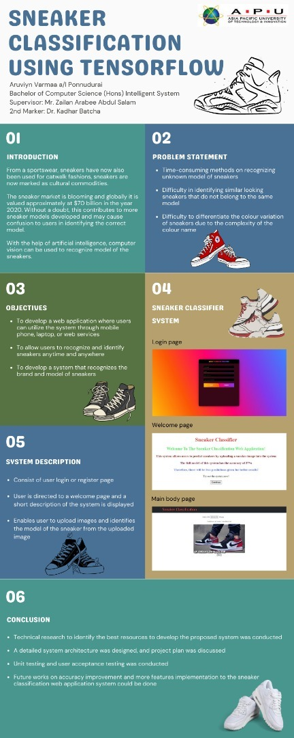

## 2.0 Log Sheet

### Project Log Sheet 1

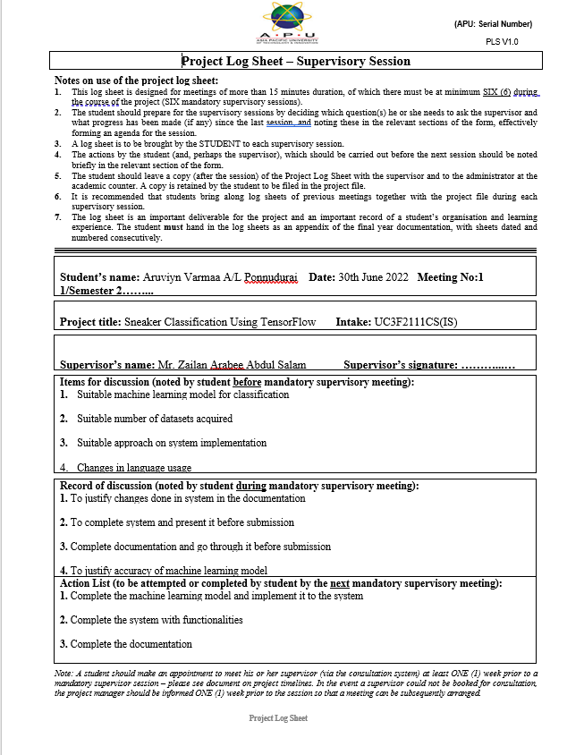

### Project Log Sheet 2



### Project Log Sheet 3



## 3.0 Ethic Form

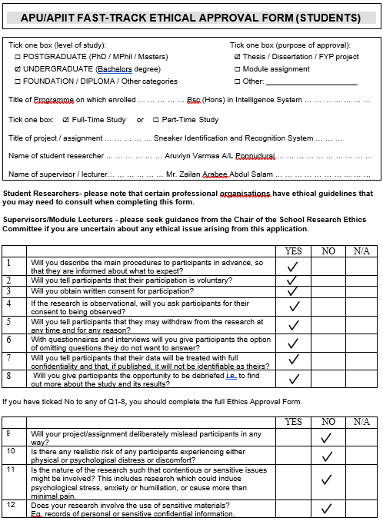

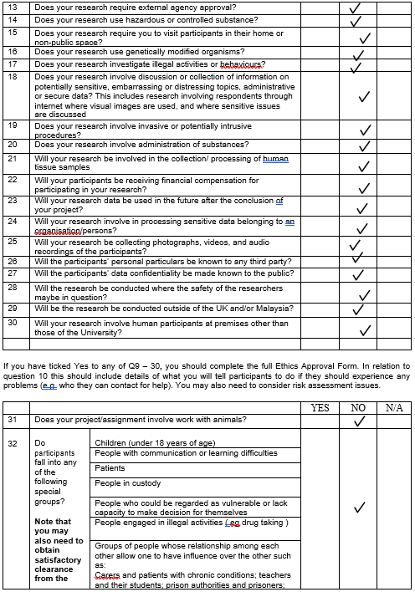

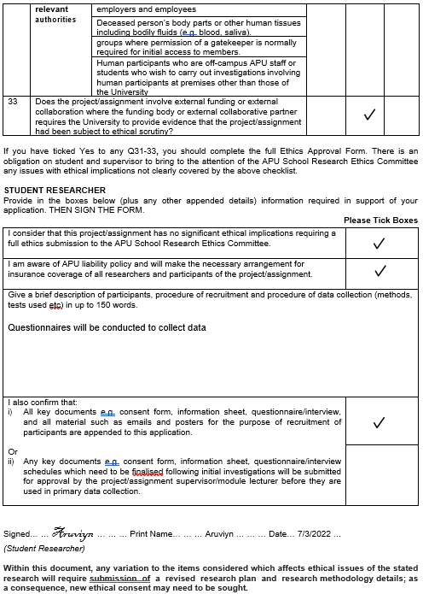



## 4.0 Project Proposal Form (PPF)

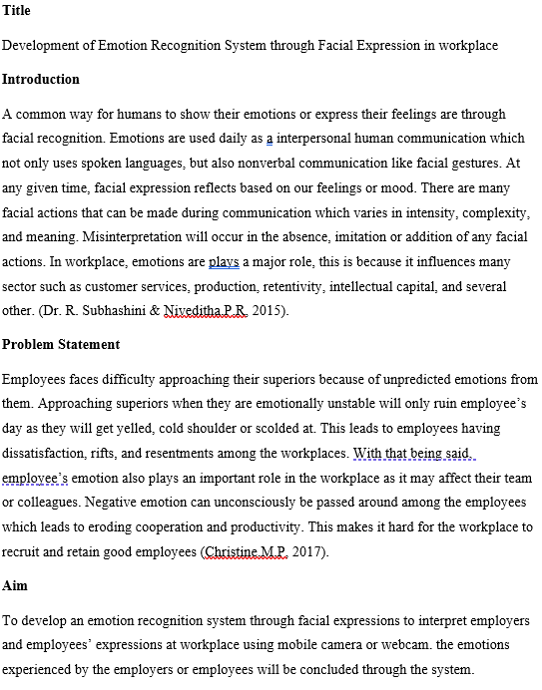

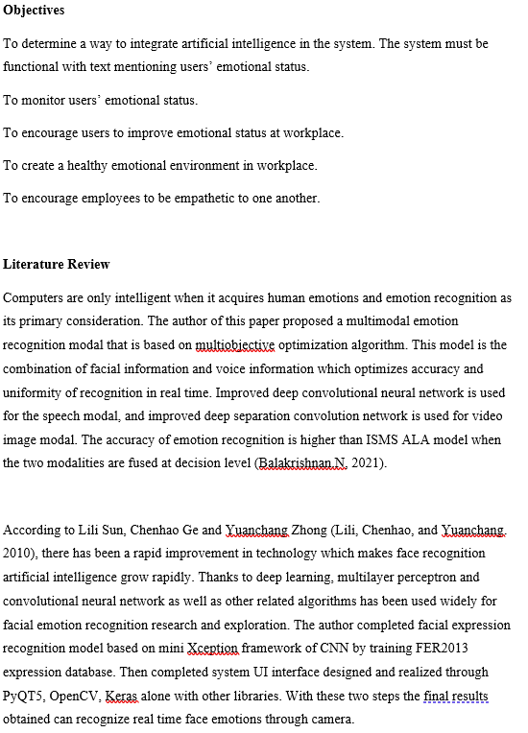

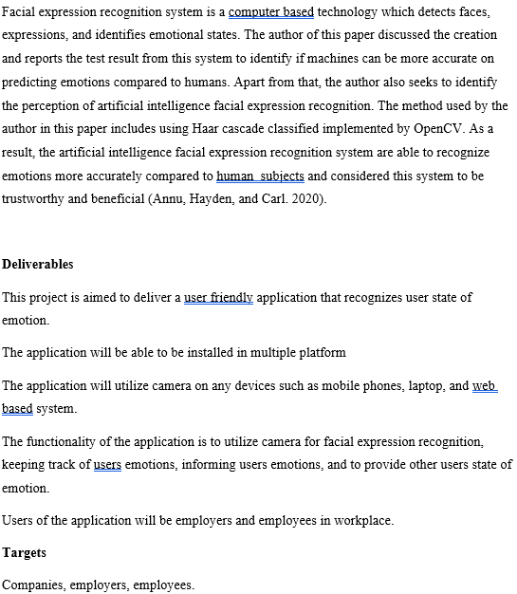

## 5.0 Project Specification Form

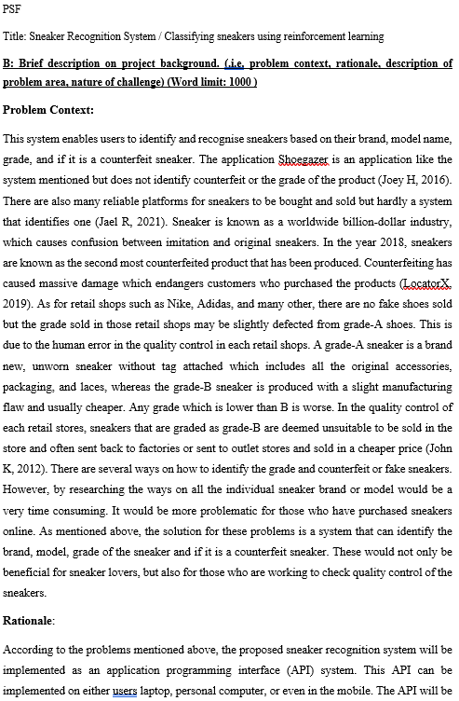

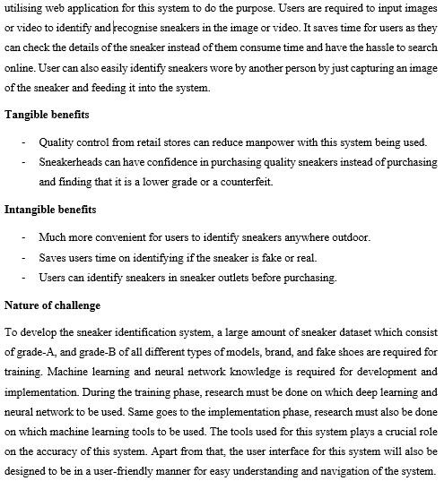

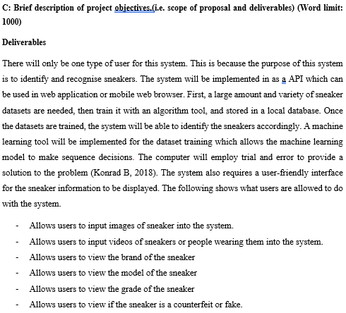

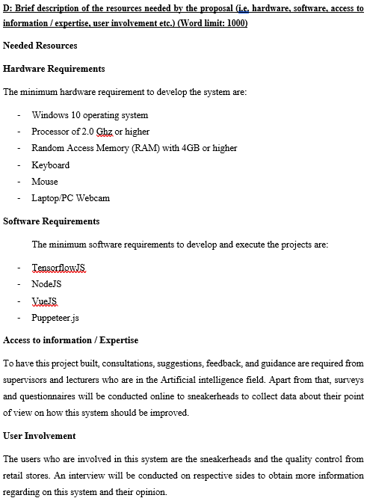

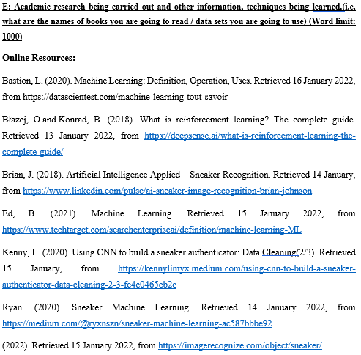



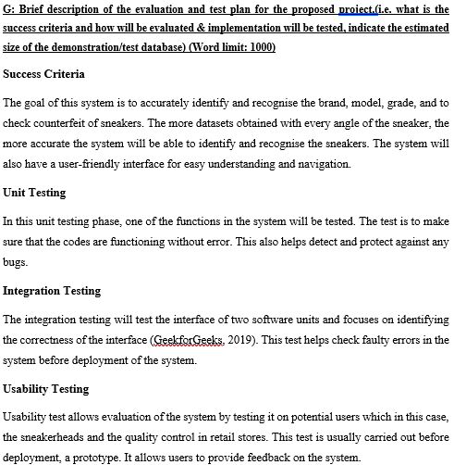

## 6.0 Gantt Chart

*Figure 7.2.5.1 Gantt Chart of Project (Self Captured, 2022)*

## 7.0 Confidentiality Form



## 8.0 Library Catalog Form

